KENDRIYA VIDYALAYA TATANAGAR

AISSE Result 2022-23
Total App: 107
Passed: 104
Pass% : 97.19

Name of the student | Marks Obtained | Marks in % | PIC
SWASTI PANDEY | 446 | 89.2
KANAK SHARMA | 450 | 90 | 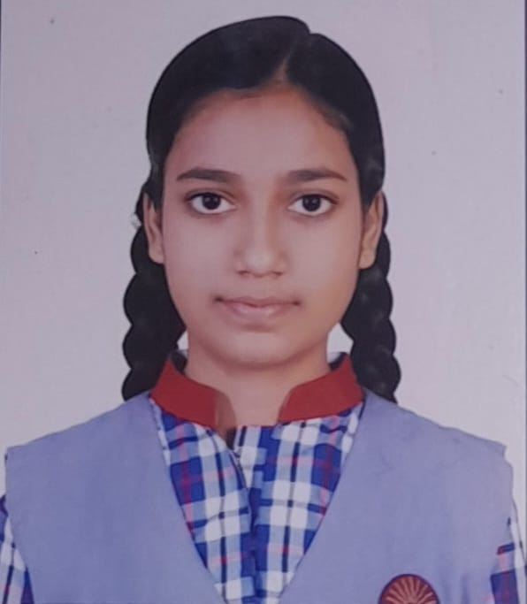
AKANKSHA KUMARI | 442 | 88.4

KENDRIYA VIDYALAYA TATANAGAR
AISSCE Result 2022-23

Total App: 114
Passed: 84
Pass% : 73.6

Name of the student | Marks Obtained | Marks in % | PIC
Science Stream
SHREYA SINGH | 446 | 89.2 | 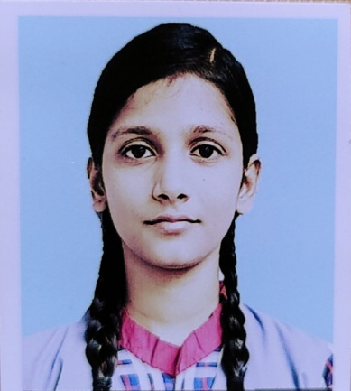
SATYAM KUMAR CHOUHAN | 427 | 85.4 | 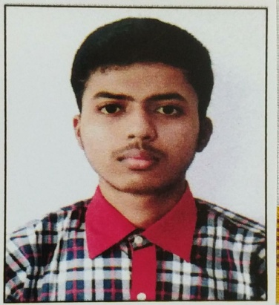
SUMAN MANDAL | 423 | 84.6 | 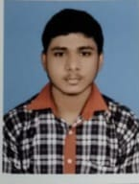
Commerce Stream
ANANYA LODH | 435 | 87 | 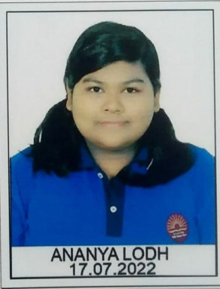
HARSH SINGH | 421 | 84.2 | 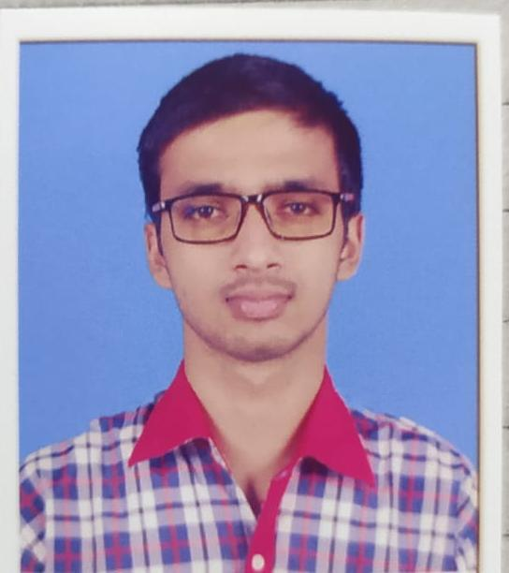
RAKHI SARDAR | 410 | 82 | 