CRITICAL AND CREATIVE THINKING TEST ITEMS

CLASS IX SUB: SCIENCE CHAPTER-15 : IMPROVEMENT IN FOOD RESOURCES
INDEX
S.No: | Topic | Page Number
1 | Article on Metabolomics
2 | Article: Role of Greenhouse Technology in Agricultural Engineering
3 | Importance of Greenhouse technology: Crop Production
4 | Fertilizers and Soil Acidity
5 | Turning a swamp into a fish farm
6 | Improvement in Food resources: Chart/Diagram analysis
7 | Dairy: Mixed Breed Vs Native Breed
8 | Integrated Pest Management
9 | Intercropping and Crop rotation for Sustainability
10 | Genetically modified Plant a Boon/ Curse
11 | Fertilizer overuse eating away Punjab’s soil nutrients
12 | Composite Soil Management

KENDRIYA VIDYALAYA SANGTHAN
REGIONAL OFFICE KOLKATA
PRACTICE ITEMS FOR SCIENTIFIC LITERACY
Domain: SCIENTIFIC LITERACY | Topic: Improvement in food resources (Chapter 15) | Class:IX
Items Prepared by Mr. Kuntal Batabyal.PGT(CHEM) KV Asansol, Kolkata Region
SCIENCE LITERACY
ITEM-1
Total Credit-10
Description of Item-Text Context-Global

Article in Metabolomics-August 2015 (Nanna H. Vidkjaer et al)
Weaver ants (genus Oecophylla) are tropical carnivorous ant species living in high numbers in the canopies of trees. The ants excrete copious amounts of faecal matter on leaf surfaces, and these faeces may provide nutrients to host trees. This hypothesis is supported by studies of ant-plant interactions involving other ant species that have demonstrated the transfer of nutrients from ants to plants. In this 7-months study, a GC–MS-based metabolomics approach along with an analysis of total nitrogen and carbon levels was used to study metabolic changes in ant-hosting Coffea arabica plants compared with control plants. The results showed elevated levels of total nitrogen, amino acids, fatty acids, caffeine, and secondary metabolites of the phenylpropanoid pathway in leaves from ant-hosting plants. Minor effects were observed for sugars, whereas little or no effect was observed for organic acids, despite the fact that lower levels of total carbon were found in ant-hosting plants. The increased levels of total nitrogen, amino acids, fatty acids and caffeine and the decreased total carbon were consistent with changes observed in plants grown with an increased supply of nitrogen-containing nutrients. The up-regulation of the phenylpropanoid pathway could indicate biotic stress and/or nutrient deficiency. However, because nutrient deficiency was contradicted by the remaining results, this pathway up-regulation was ascribed to biotic stress caused by the physical presence of the weaver ants.
QUESTION 1.1
Investigate to find out the probable reason of elevated levels of total Nitrogen, amino acids etc. in leaves of ant hosting plants.
____________________________________________________________________________________________________________________________________________________________________________________________________________________________________________________________________________________________________________
QUESTION 1.2
Explain the term “Biotic Stress”
______________________________________________________________________________________________________________________________________________________________________________________________________________________________________________________

Study the Graph obtained after seven months of study carefully to answer the following questions
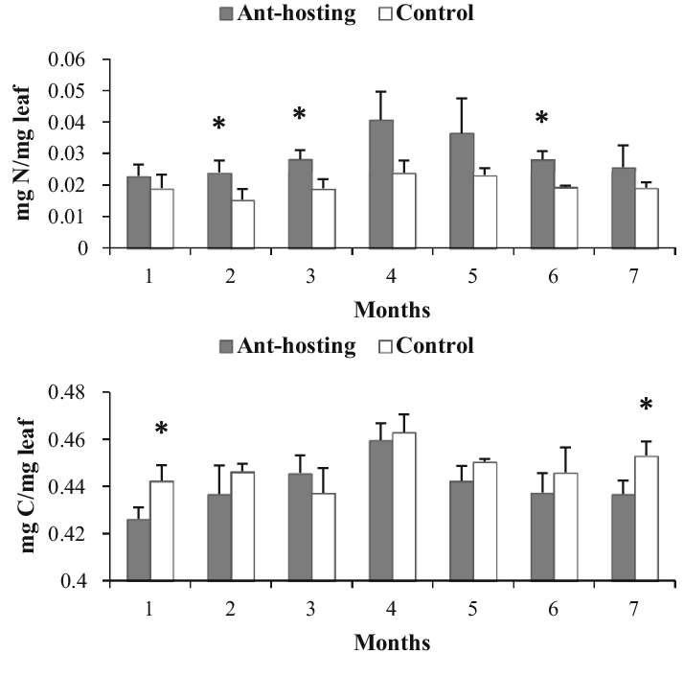
Total Nitrogen and Carbon content in dried leaves from ant hosting and control plants from 1 to 7 months study.
QUESTION 1.3
Find out the Element whose amount was found to be elevated on the leaves of ant hosting plants compared to leaves of control plants and during which month its maximum amount was found?
____________________________________________________________________________________________________________________________________________________________________________________________________________________________________________________________________________________________________________
QUESTION 1.4
Which of the following statements are true for Amino acids?
- Amino acids are found in sugars,
- Amino acids are building block of proteins.
- Glycine and alanine are examples of amino acids.
- Amino acids are polymeric molecules.
____________________________________________________________________________________________________________________________________________________________________
QUESTION 1.5
Chose the correct option
- Which among the following is a non-opium alkaloid?
A) Morphine B) Codeine C) Caffeine D) Thebaine
- When organic matter with wide C : N (70 : 1) is added to the soil, the net effect is the disappearance of mineral Nitrogen is due to

- Mineralization B) Immobilization C) N₂ Reduction D) N₂ transformation

KENDRIYA VIDYALAYA SANGATHAN, KOLKATA REGION
CCT PRACTICE ITEMS FOR SCIENTIFIC LITERACY

Template -1
Domain: Scientific Literacy | Theme: Improvement in food resources (Chapter 15)  CONCEPT- Are Ant faces nutrients to plants? | CLASS: IX  Expected time: 20minutes  Total Credit:10
Description of Item: Text and Graph | Learning Outcome: Conducts simple investigations to seek answers to queries.  Applies learning of scientific concepts in day-to-day life.  Able to interpret the data given in the Graph.

S.No | Competency | Knowledge-system | Cognitive demand | Item format | Proficiency Level
1.1 | Explain phenomena scientifically(Make and justify appropriate predictions) | Living system | High | Constructed response(closed) | Level 6
1.2 | Explain phenomena scientifically(Recall and apply appropriate scientific knowledge) | Living system | Medium | Constructed response(closed) | Level 2
1.3 | Interpret data and evidences successfully (Evaluate scientific arguments and evidences from different sources.) | Living system | Medium | Constructed response(Closed) | Level 4
1.4 | Explain phenomena scientifically(Make and justify appropriate prediction) | Living system | Low | Complex multiple choice | Level 3
1.5 | Explain phenomena scientifically(Recall and apply appropriate scientific knowledge) | Living system | Low | Simple multiple choice | Level 2

Credit Pattern: Full Credit: 02Partial Credit: 01No Credit: 0
DESCRIPTION OF ANSWER KEY AND CREDITS:

1.1 Full Credit:-The ants excrete copious amounts of faecal matter on leaf surfaces, and these faces may provide nutrients to host trees which results into elevated amount of Nitrogen, amino acids etc. on leaves of ant hosting plants. (02 Marks)
No Credits: any other answer (0)

1.2 Full Credits: - Correct definition (Negative influences caused by other living organisms like in agriculture it refers to damage caused by insects, bacteria, fungi or weeds etc.
No Credits: any other answer (0)

1.3 Full Credit: Nitrogen and during 4th month. (2)
Partial Credit: Any one correct answer. (1)
No Credits: any other answer (0)

1.4 Full Credit: - Statement No ii) and iii) (2)
Partial Credit: - Any one correct answer (1)
No Credits: any other answer (0)

1.5 Full Credit: - Correct option i) C and ii) D
Partial Credit: - Any one correct answer (1)
No Credits: any other answer (0)

Domain: SCIENTIFIC LITERACY | Topic: Improvement in food resources (Chapter 15) | Class: IX

ITEM 2
Total Credit-10
Description of Item-Text and Image Context-Global
Research Article: Role of Greenhouse Technology in Agricultural Engineering (Anil Kumar, G.N. Tiwari , Subodh Kumar and Mukesh Pandey)

Importance of Greenhouse Technology: Crop Production
Around 80% of the world population lives in the developing countries (Anonymous, 1995). Undoubtedly, the agricultural production must be increased to guarantee the food demand of the fast-growing population. In the next 25 years around 50% more food has to be produced, mainly in developing countries (Brown, 1995).

India has attained the self-sufficiency in food and food products. The food grains production has increased from 50.8 million tonnes in year 1951 to 208.9 million tonnes in year 2000 (Anonymous, 2001a) whereas, the area has increased from 97.3 to 123.1 million ha under food grains over these 50 years. India accounts for nearly 10% of world production of fruit crops with annual production of about 44-46 million tonnes. India is the second largest producer of vegetables, next to China. In 1998-99, an estimated production of 87.5 million tonnes, accounted for 14.4% of the world production of vegetables (Anonymous, 2001a).

In the present scenario, to meet the worldwide demand of enhanced production, greenhouse cultivation could serve as a viable solution, facilitating off-season cultivation and protecting crop from unfavourable outdoor conditions. Apart from these, a greenhouse could be a better option for nursery raising, hardening of tissue culture plants, cultivation in regions which are prone to soil problems and extreme climates, also for cultivation of rare as well as medicinal plants.
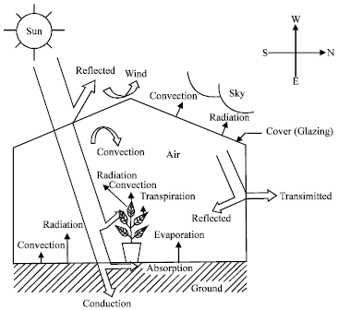

Energy flow processes in greenhouse system

QUESTION 2.1
Find out the possible reason how Green House increases Crop Production?
____________________________________________________________________________________________________________________________________________________________________________________________________________________________________________________________________________________________________________

QUESTION 2.2
Analyse the fact that increased temperature increases the Crop yield?
____________________________________________________________________________________________________________________________________________________________________________________________________________________________________________________________________________________________________________

QUESTION 2.3
As Green House Effect results into Global Warming. What changes in natural ecosystems are caused by the ongoing global warming process?
____________________________________________________________________________________________________________________________________________________________________________________________________________________________________________________________________________________________________________
QUESTION 2.4.1
Find the correct option
Solar radiations consist of
- Visible radiation
- Ultra Violet Radiations
- Infra-red radiations
- All of the above radiations.

QUESTION 2.4.2
Out of the following gases find out the gas which is not a greenhouse gas?
- Methane
- Carbon di oxide
- Argon
- Ozone

QUESTIONS 2.5
Observe the Diagram related to Greenhouse effect at micro level, and identify the short-wave length solar radiation and long wavelength radiation.
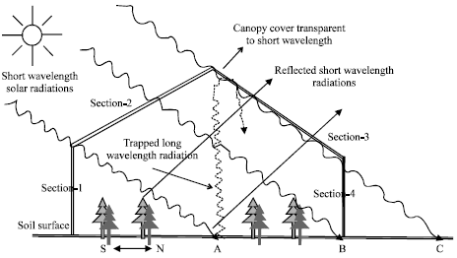
______________________________________________________________________________________________________________________________________________________________________________________________________________________________________________________

KENDRIYA VIDYALAYA SANGATHAN, KOLKATA REGION
CCT PRACTICE ITEMS FOR SCIENTIFIC LITERACY
Template -2
Domain: Scientific Literacy | Theme: Theme: Improvement in food resources (Chapter 15)  Importance of Greenhouse Technology: Crop Production | CLASS: VIII  Expected time: 20 minutes  Total Credit:10
Description of Item: Text | Learning Outcome: Conducts simple investigations to seek answers to queries of Green House effect and crop cultivation. Identifies the Factors that boosts the growth of crops in Green House,  Applies learning of scientific concepts in day-to-day life.

Q.No | Competency | Knowledge-system | Cognitive demand | Item format | Proficiency Level
2.1 | Explain phenomena scientifically(Recall and apply appropriate scientific knowledge) | Living system | Medium | Constructed response(Closed) | Level 3
2.2 | Evaluate and design scientific inquiry | Living system | Medium | Constructed response(closed) | Level 4
2.3 | Explain phenomena scientifically(Explain the potential implications of scientific knowledge for society) | Living system | Medium | Constructed response(open) | Level 5
2.4.1 | Explain phenomena scientifically(Recall and apply appropriate scientific knowledge) | Living system | Low | Simple multiple choice | Level 2
2.4.2. | Explain phenomena scientifically(Recall and apply appropriate scientific knowledge) | Living system | Low | Simple multiple choice | Level 2
2.5. | Explain phenomena scientifically(Recall and apply appropriate scientific knowledge) | Living system | Medium | Constructed response(open) | Level 4

Credit Pattern:
Full Credit: 02
Partial Credit: 01
No Credit: 0

DESCRIPTION OF ANSWER KEY AND CREDITS:
  - Full credit- Conditions are kept at the optimum for growth, including the use of Artificial lighting, trapping of heat from sun.
No Credit: Any other irrelevant answer or missing answer.

2.2 Full credit : Enzymes work more efficiently at higher temperature making reaction rate faster and we know Enzymes are involved in key growth process and photosynthesis.
Partial Credit: Correct answer for only mentioning faster reaction rate or higher enzyme activity.
No Credit: Any other irrelevant answer or missing answer.

2.3 Full Credit: Different species of flora and fauna change their habitats and geographical areas according to climate change and specific geographical environments.
Areas of occurrence of specific species, for example insects in terrestrial areas and fish and arthropods in the seas and oceans, change.
For example, bird habitats change, so migrations of some bird species may also be subject to modification. In the situation when forest areas dry out and turn into steppes and deserts, changes in natural habitats and areas of occurrence of species change and concern simultaneously many species of flora and fauna.

  - Partial Credit: Only mentioning about climate change
No Credit: Any other irrelevant answer or missing answer

2.4. Full Credit: Correct options 2.4.1 Option D and 2.4.2 Option C
Partial Credit: Any one correct answer.
No Credit: Any other irrelevant answer or missing answer.
2.5 Full Credit: Short wave length solar radiations are Visible and UV and Long wave length solar radiation is IR radiations.
No Credit: Any other irrelevant answer or missing answer

KUNTAL BATABYAL
PGT CHEMISTRY.KV ASANSOL
rushtokuntal@gmail.com
Mobile:9933912040
Kendriya Vidyalaya Asansol
Kolkata Region
ITEM-3
Domain: SCIENTIFIC LITERACY | Topic: Improvement in food resources (Chapter 15) | Class: IX

Total Credit-10
Description of Item-Text and Image Context-Global

FERTILIZERS AND SOIL ACIDITY
Soil acidification is a natural process in high rainfall environments where leaching slowly acidifies soil over time. Intensive agriculture can speed up soil acidification through many processes – increasing leaching, addition of fertilizers, removal of produce and build-up of soil organic matter. Of all the major fertilizer nutrients, nitrogen is the main nutrient affecting soil pH, and soils can become more acidic or more alkaline depending on the type of nitrogen fertilizer used. Nitrate-based products are the least acidifying of the nitrogen fertilizers, while ammonium-based products have the greatest potential to acidify soil. Soil acidification due to use of phosphorus fertilizers is small compared to that attributed to nitrogen, due to the lower amounts of this nutrient used and the lower acidification per kg phosphorus. Phosphoric acid is the most acidifying phosphorus fertilizer. Potassium fertilizers have little or no effect on soil pH.
Fertilizer use
Use of mineral or organic fertilizers in agriculture increases inputs of nutrients to soils, and the form in which the nutrients are applied and their fate in the soil-plant system determine the overall effects on soil pH. Macronutrients (N, P, potassium (K), and S) have the major effects on pH as they are added in much larger quantities to soil than micronutrients.

QUESTION 3.1
Identify any two reasons behind soil acidity.

QUESTION 3.2
Analyse the Diagram given below and study the effect of adding phosphate fertilizers in soil and try to find out the answer of the following question.
What is pH of DAP (Di Ammonium Phosphate) after soil application?
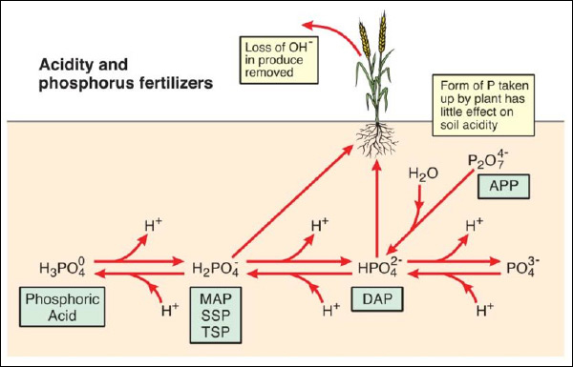
______________________________________________________________________________________________________________________________________________________________________________________________________________________________________________________

QUESTION 3.3
When excess fertilisers are put on the soil, the soil may become acidic.
Critically analyse the fact that why is it important to farmers that the soil does not become too acidic? (Mention any two possible effects.)
________________________________________________________________________________________________________________________________________________________________________________________________________________________________________________________________________________________________________________________________________
QUESTION 3.4
Suggest an economical method to regulate soil acidity and explain how it works?
____________________________________________________________________________________________________________________________________________________________________
QUESTION 3.5
Chose the Correct option.

QUESTION 3.5.1
This chemical fertilizer is essential for better rhizobial nitrogen fixation
(a) calcium
(b) potassium
(c) sodium
(d) phosphorus

QUESTION 3.5.2
In children, this disease is caused due to excess nitrate fertilizers usage
(a) mumps
(b) jaundice
(c) septicaemia
(d) methaemoglobinaemia

KENDRIYA VIDYALAYA SANGATHAN, KOLKATA REGION
CCT PRACTICE ITEMS FOR SCIENTIFIC LITERACY
Template -3

Domain: Scientific Literacy | Theme: : Improvement in food resources (Chapter 15)  CONCEPT- FERTILIZERS AND SOIL ACIDITY | CLASS: IX  Expected time: 20minutes  Total Credit:10
Description of Item: Text | Learning Outcome:Conducts simple investigations to seek answers to queries of Harmful effects use of excess nitrogenous and phosphate fertilizers on soil acidity.  Identifies the fact that soil acidity can be regulated.  Applies learning of scientific concepts in day-to-day life,

Q.No | Competency | Knowledge-system | Cognitive demand | Item format | Proficiency Level
3.1 | Evaluate and design scientific inquiry | Living system | Low | Constructed response(closed) | Level 2
3.2 | Interpret data and evidences successfully (Evaluate scientific arguments and evidences from different sources.) | Living system | Medium | Constructed response(closed) | Level 3
3.3 | Explain phenomena scientifically(Make and justify appropriate prediction) | Living system | Medium | Constructed response(open) | Level 4
3.4 | Explain phenomena scientifically(Make and justify appropriate prediction) | Living system | Low | Constructed response(open) | Level 5
3.5. | Explain phenomena scientifically(Recall and apply appropriate scientific knowledge) | Living system | Medium | Simple Multiple choice | Level2

Credit Pattern:
Full Credit: 02
Partial Credit: 01
No Credit: 0

DESCRIPTION OF ANSWER KEY AND CREDITS:
3.1 Full credit: Soil acidification is a natural process accelerated by agriculture. Soil acidifies because the concentration of hydrogen ions in the soil increases. The main cause of soil acidification is 1) inefficient use of nitrogen, followed by the export of alkalinity in produce.
Ammonium based fertilisers are major contributors to soil acidification. Ammonium nitrogen is readily converted to nitrate and hydrogen ions in the soil. If nitrate is not taken-up by plants, it can leach away from the root zone leaving behind hydrogen ions thereby increasing soil acidity
2)Removal of produce and build-up of soil organic matter
3) Leaching and absorption of metal ions like Ca,Mg etc.
Partial Credit: Correct answer of any one reason
No Credit: Any other irrelevant answer or missing answer

3.2 Full credit: Diammonium phosphate is a salt of weak base (3<pKb<6, ammonia) and moderately strong acid (H3PO4). Therefore, the initial pH of this sort of fertiliser/salts are slightly basic due to hydrolysis reaction of phosphate anion which produce OH - ions.
Partial Credit: Only mentioning the fact that soil become slightly alkaline.
No Credit: Any other irrelevant answer or missing answer.

3.3 Full Credit: (Any two possible effects)
Aluminium toxicity: When soil pH drops, aluminium becomes soluble. A small drop in pH can result in a large increase in soluble aluminium .In this form, aluminium retards root growth, restricting access to water and nutrients
Nutrient availability: In very acid soils, all the major plant nutrients (nitrogen, phosphorus, potassium, sulphur, calcium, manganese and also the trace element molybdenum) may be unavailable, or only available in insufficient quantities. Plants can show deficiency symptoms despite adequate fertiliser application.
Microbial activity: Low pH in topsoils may affect microbial activity, most notably decreasing legume nodulation
Partial Credit: Mentioning any one possible effect.
No Credit: Any other irrelevant answer or missing answer

3.4 Full Credit: Soil acidity can be corrected easily by liming the soil, or adding basic materials to neutralize the acid present. The most commonly used liming material is agricultural limestone, the most economical and relatively easy to manage source. The limestone is not very water-soluble, making it easy to handle .As lime mixes in the soil, calcium (Ca²⁺) moves to the surface of soil particles, replacing the acidity. The H+ ion reacts with the carbonate (CO₃ ²⁻) to form carbon dioxide (CO₂) and water (H₂O). The result is a soil that is less acidic (has a higher pH).
Partial Credit: Any one correct reason
No Credit: Any other irrelevant answer or missing answer

3.5 Full Credit:3.5.1 Option D 3.5.2 Option D
Partial Credit: Any one correctanswer
No Credit: No correct answer or missing answer.

KUNTAL BATABYAL
PGT CHEMISTRY.KV ASANSOL
rushtokuntal@gmail.com
Mobile:9933912040
Kendriya Vidyalaya Asansol
Kolkata Region

ITEM-4
Domain: SCIENTIFIC LITERACY | Topic: Improvement in food resources (Chapter 15) | Class: IX
Total Credit-10
Description of Item- Newspaper Article and Image Context: Local

Topic: Turning a swamp into fish farm
Daily Star Article By: Jahirul Islam Jewel with Andrew Eagle, November 21, 2015
“It's a great pleasure to feed the fish each day,” says an enthusiastic Kajol Rani Howlader of Choupala Bazar in Jhalakathi sadar upazila, standing beside an unlikely fish enclosure built on swampy, disused marshy land. “We have thousands of fish and after throwing feed, there are so many that anybody can touch them,” she says. Kajol Rani is participating in a new style of pisciculture and vegetable growing project that aims to utilise waterlogged non-agricultural land to improve people's lives.
To ask the ten women in the group of thirty locals involved in the project, is to hear how their husbands used to pass days in idle gossip in teashops while wives were busy with household chores. It all changed last July, thanks to the BRAC-organised project, championed in particular by the women.
Md Shahalam Mia, the team's group leader, says, “At first we managed fifteen acres. It was covered in weeds and water hyacinth. We made the enclosure there, in preparation for fish production. “The weeds and hyacinth were meanwhile used in creating floating beds for simultaneous vegetable farming.
“Our project cost was about four lakh takas, including the purchase of fish fry,” Mia explains. BRAC helped with finance but each group member has invested 5,000 takas.
The aim is for each family to achieve up to twenty-thousand-taka profit when the first fish are sold later this month. Choosing indigenous fish species and carp has proved wise, with most fish already reaching one kilogram in weight.
“We never imagined such success in such a short time,” several women participants say. “It's like a dream to us!”

QUESTION 4.1
Aquaculture (fish farming) is carried out in a series of ponds on the marsh. (i) Suggest why the marsh area is suitable for the ponds.
_______________________________________________________________________________________________________________________________________________________________________________________________________________________________________________________________________________________________________________________________________________________________________________________
QUESTION 4.2
Find out two features of fish that make them suitable for farming.
____________________________________________________________________________________________________________________________________________________________________________________________________________________________________________________________________________________________________________

QUESTION 4.3
Go through the image given below related to Eutrophication of Fish ponds. Explain how this Eutrophic condition often prevail in fish ponds adjacent to agricultural lands and how it affects the Biodiversity of the pond?
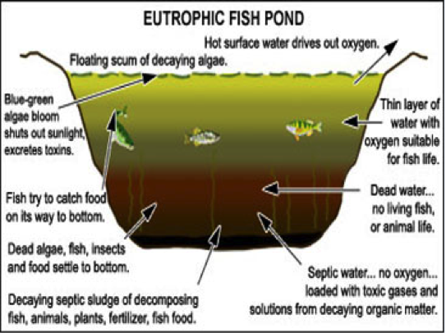
_________________________________________________________________________________________________________________________________________________________________________________________________________________________________
QUESTION 4.4
How do you react to the statement that aquaculture can damage the environment?
____________________________________________________________________________________________________________________________________________________________________________________________________________________________________________________________________________________________________________

QUESTION 4.5 Tick the appropriate box

Statement | Fact | Myth
- Farmed fish is not safe to eat
- Fish farming enables selective breeding of fish to ensure high quality and fast-growing fish.

Template -4

Domain: Scientific Literacy | Theme: : Improvement in food resources (Chapter 15)  CONCEPT- Turning a swamp into fish farm | CLASS:IX  Expected time: 20 minutes  Total Credit:10
Description of Item: Text | Learning Outcome:Conducts simple investigations to seek answers to queries of fish farming in marshy land.  Learn the conditions of development of aquatic organisms and its habitat conditions, formation and change patterns of yielding in relate with the environmental changes of anthropogenic influence.

Q.No | Competency | Knowledge-system | Cognitive demand | Item format | Proficiency Level
4.1 | Explain phenomena scientifically(Make and justify appropriate prediction) | Living system | Medium | Constructed response(Closed) | Level 3
4.2 | Explain phenomena scientifically(Recall and apply appropriate scientific knowledge) | Living system | Medium | Constructed response(open) | Level 3
4.3 | Explain phenomena scientifically(Make and justify appropriate prediction) | Living system | High | Constructed response(open) | Level 5
4.4 | Explain phenomena scientifically(Drawing or evaluating conclusion) | Living system | High | Constructed response(open) | Level-6
4.5. | Explain phenomena scientifically(Make and justify appropriate prediction) | Living system | Low | Binary Choice | Level2

Credit Pattern:
Full Credit: 02
Partial Credit: 01
No Credit: 0

DESCRIPTION OF ANSWER KEY AND CREDITS:

4.1 Full Credit: A marsh pond, replicates the transition between wet soil and open water that would typically be found at the edge of naturally occurring earth ponds. This environment supports a wide range of aquatic plants ranging from plants that live in damp soils, to plants that require several inches of water, to floating and submerged aquatic plants found in open water. This environmental diversity also attracts a wide range of animal life including fish.
Partial Credit: Partially correct answer.
No Credit: Any other irrelevant answer or missing answer.

4.2 Full Credit: Any two correct factors
- Should grow fast easy to breed;
- Preferably herbivorous compatible with other species;
- Should have consumer preference.
- Should have high nutrient content including protein.

Partial Credit: Any one correct factor.
No Credit: Any other irrelevant answer or missing answer

4.3 Full Credit: The excess nutrient and fertilizers leached into fish pond boosts up excessive algae growth due to which aquatic animals get deprived of dissolved Oxygen. Eutrophication leads to changes in the availability of light and certain nutrients to an ecosystem. This causes shifts in the species composition so that only the more tolerant species survive and new competitive species invade and out-compete original inhabitants. Examples are macro algae and their massive biomass which inhibits the growth of other aquatic plants and algal blooms that consists of one type of phytoplankton species because other species are expelled.
Partial Credit: Any one of the correct answers.
No Credit: No correct answer or missing answer

4.4Full Credit: The following points of arguments can be put forward
Nutrient build-up
This is one of the most frequently talked about impacts of open water aquaculture. Nutrients build up in the environment surrounding the fish because there is nothing to prevent dead fish, food that isn’t eaten and faeces entering the water
Transmission of disease
Having a large number of fishes kept closely together in a small area means that any diseases or parasites are likely to spread much more quickly.
Antibiotics
Various drugs are used in aquaculture to prevent disease outbreaks, increase growth and prevent parasites.
When these antibiotics enter the natural environment, they can either have direct impacts on sea life or can cause resistance to develop which can be problematic further down the line.
So, like any other human activity, aquaculture must be managed sustainably and responsibly. But fish farmers must also play a wider proactive role in protecting the environment: for instance, aquaculture ponds help preserve important natural landscapes and habitats for wild birds and other endangered species.

Partial Credit: Any one of the positive or negative impacts.
No Credit: Any other irrelevant answer or missing answer.

4.5 Full Credit: (A) Myth, (B) Fact

Partial Credit: Any one correct answer

No Credit: Any other answer or missing answer.

KUNTAL BATABYAL
PGT CHEMISTRY.KV ASANSOL
rushtokuntal@gmail.com
Mobile:9933912040
Kendriya Vidyalaya Asansol
Kolkata Region

ITEM-5
Domain: SCIENTIFIC LITERACY | Topic: Improvement in food resources (Chapter 15) | Class: IX

Description of Item-Chart/Diagram Context-Global

Total Credit-10
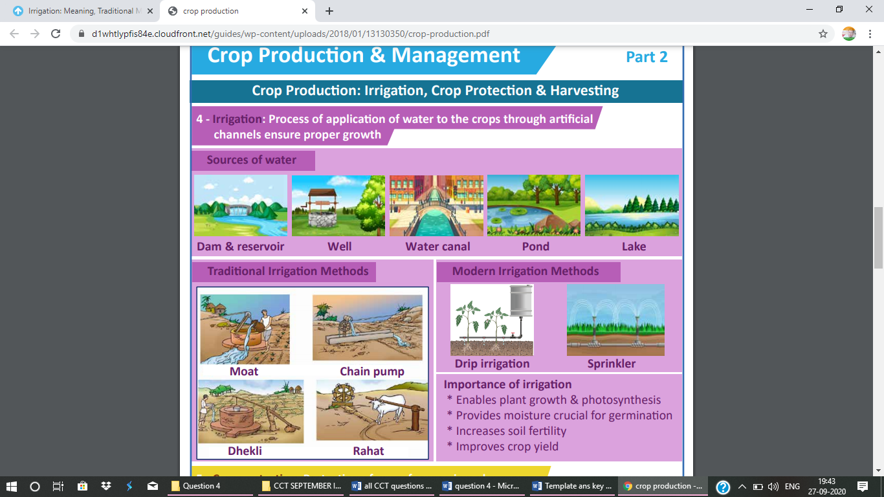

QUESTION 5.1
Find out the possible reasons behind irrigating the crop field.
_________________________________________________________________________________________________________________________________________________________________________________________________________________________________

QUESTION 5.2
List out two main advantages of modern methods of irrigation over the traditional ones.
____________________________________________________________________________________________________________________________________________________________________________________________________________________________________________________________________________________________________________

QUESTION 5.3
Suggest two ideas for effective use of Rain water for agriculture.
____________________________________________________________________________________________________________________________________________________________________________________________________________________________________________________________________________________________________________

QUESTION 5.4
Name two methods of irrigation that conserves water.
_________________________________________________________________________________________________________________________________________________________________________________________________________________________________
QUESTION 5.5
Which system is a boon in regions of poor availability of water and why?
____________________________________________________________________________________________________________________________________________________________________________________________________________________________________________________________________________________________________________

Template -5

Domain: Scientific Literacy | Theme: : Improvement in food resources (Chapter 15)  CONCEPT- Methods of Irrigation | CLASS:IX  Expected time: 15 minutes  Total Credit:10
Description of Item: Text | Learning Outcome:Conducts simple investigations to seek answers to queries of different methods of irrigation and able to compare between them.  Identifies the need for irrigation.

Q.No | Competency | Knowledge-system | Cognitive demand | Item format | Proficiency Level
5.1 | Explain phenomena scientifically(Make and justify appropriate prediction) | Living system | Medium | Constructed response(Closed) | Level 3
5.2 | Explain phenomena scientifically(Recall and apply appropriate scientific knowledge) | Living system | Medium | Constructed response(open) | Level 3
5.3 | Explain phenomena scientifically(Make and justify appropriate prediction) | Living system | High | Constructed response(open) | Level 5
5.4 | Explain phenomena scientifically(Recall and apply appropriate scientific knowledge) | Living system | Low | Constructed response(closed) | Level-2
5.5. | Explain phenomena scientifically(Make and justify appropriate prediction) | Living system | Medium | Constructed response(closed) | Level3

Credit Pattern:
Full Credit: 02
Partial Credit: 01
No Credit: 0

DESCRIPTION OF ANSWER KEY AND CREDITS:

5.1 Full Credit: Correct answer
Partial Credit: Partially correct answer.
No Credit: Any other irrelevant answer or missing answer.
5.2 Full Credit: Any two correct advantages

Partial Credit: Any one correct advantage.
No Credit: Any other irrelevant answer or missing answer

5.3 Full Credit: Any two correct ideas.
Partial Credit: Any one of the correct ideas.
No Credit: No correct answer or missing answer.
5.4 Full Credit: Drip system and Sprinkler system.
Partial Credit: Any one correct system.
No Credit: Any other irrelevant answer or missing answer

5.4 Full Credit: Drip system and Correct explanation.
Partial Credit: Any one correct system.
No Credit: Any other irrelevant answer or missing answer

KUNTAL BATABYAL
PGT CHEMISTRY.KV ASANSOL
rushtokuntal@gmail.com
Mobile:9933912040
Kendriya Vidyalaya Asansol
Kolkata Region

KENDRIYA VIDYALAYA SANGTHAN
REGIONAL OFFICE KOLKATA
PRACTICE ITEMS FOR SCIENTIFIC LITERACY
Domain: SCIENTIFIC LITERACY | Topic: IMPROVEMENT IN FOOD RESOURCES | Class: IX

Items Prepared by Mr.Sabitabrata Mandal.PGT(BIO) KV Ballygunge, Kolkata Region
SCIENCE LITERACY
DAIRY - MIXED BREED Vs NATIVE BREED
India ranks first among the world’s milk producing Nations since 1998 and has the largest bovine population in the World. Milk production in India during the period 1950-51 to 2017-18, has increased from 17 million tonnes to 176.4 million tonnes as compared to 165.4 million tonnes during 2016-17 recording a growth of 6.65 %. FAO reported 1.46% increase in world milk Production from 800.2 million tonnes in 2016 to 811.9(Estim) million tonnes in 2017.

How much of the milk revolution is because of the exotic germplasm? In order to give a fair answer, we will have to assume that the number of cattle would have been the same, i.e. all of the current crossbreeds were replaced by desi cattle. Since the yield of desi cattle under intensive feeding conditions is about one-third of the crossbreeds, instead of 38.66 million tonnes obtained from the crossbreeds today we would have obtained about 13 million tonnes. This amounts to about 20 per cent reduction in the total bovine milk yield. So, if the exotics were not introduced but the other components of Operation Flood remained unchanged, India’s net milk productivity would have increased by 6.4 folds instead of 8 folds. Is it possible that the money spent on the AI programme or equal amount spent on improvement and selective propagation of local breeds would have given more or less the same result? Introduction of Transgenic cows can bring a qualitative and quantitative improvement in the milk of mixed breeds. Research is required on the impact studies of these improvements in cows.

6.1
What is the percentage increased in the milk production since independence of India?
a)1037.6%
b)103.7%
c)937.6%
d)1057.6%
___________________________________________________________________________
6.2.
What may be the two very important factors responsible for the increase in the milk production during operation flood? i) introduction of Artificial Insemination ii) connecting the milk sheds with metro for market iii) co- operative movement iv) improved feeding.
a)i&ii
b)ii&iii
c)iii&iv
d)i&iv
___________________________________________________________________________
6.3.
How can we design the quantitative impact of mixed breed in the milk production of India during Operation Flood?
……………………………………………………………………………………………………………………………………………………………………………………………………………………………………………………………………………………………………………………………………………………………………………………………………………………………………………………………………………………………………………………………………………………………………………………………….

6.4.a
We should use transgenic cows in milk production?
YES
NO

6.4.b
How do you justify your answer?
……………………………………………………………………………………………………………………………………………………………………………………………………………………………………………………………………………………………………………………………………………………………………………………………………………………………………………………………………………………………………………………………………………………………………………………………………………………………………………………………………………………………………………………………………………….

6.5.
What may be the probable problems in diary animals due to selective breeding?
………………………………………………………………………………………………………………………………………………………………………………………………………………………………………………………………………………………………………………………………………………………………………………………………………………………………………………………………………………………………………………………………………………………………………………………………………………………………………………………
___________________________________________________________________________

KENDRIYA VIDYALAYA SANGATHAN, KOLKATA REGION
CCT PRACTICE ITEMS FOR SCIENTIFIC LITERACY
Template -1

Domain: Scientific Literacy | Theme: IMPROVEMENT IN FOOD RESOURCES  CONCEPT- SIGNIFICANCE OF LOCAL AND CROSS BREED | CLASS: IX  Expected time: 15minutes  Total Credit:10
Description of Item: Text | Learning Outcome: ABLE TO EVALUATE THE SIGNIFICANCE OF BREED IN OPERATION FLOOD  ABLE TO ANALYSE THE EVOLUTIONARY SIGNIFICANCE OF SELECTIVE BREEDING  ABLE TO TRANSLATE THE INFORMATION IN OTHER FORM  ABLE TO SEE RELATIONSHIP BETWEEN CAUSE AND EFFECT

Scientific Literacy
QUESTION NO. 6.1
FRAMEWORK | CHARACTERISTICS
COMPETENCY | Explain the phenomena scientifically
KNOWLEDGE SYSTEM | Content knowledge
CONTEXT | Local
COGNITIVE DEMAND | Low
ITEM FORMAT | MCQ
PROFICIENCY LEVEL | 2

QUESTION NO.6. 2
FRAMEWORK | CHARACTERISTICS
COMPETENCY | Interpret data and evidence scientifically
KNOWLEDGE SYSTEM | Content knowledge
CONTEXT | LOCAL
COGNITIVE DEMAND | LOW
ITEM FORMAT | C MCQ
PROFICIENCY LEVEL | 2

QUESTION NO. 6.3
FRAMEWORK | CHARACTERISTICS
COMPETENCY | Evaluate and design scientific inquiry
KNOWLEDGE SYSTEM | Epistemic knowledge
CONTEXT | Local
COGNITIVE DEMAND | Medium
ITEM FORMAT | Open constructed
PROFICIENCY LEVEL | 3

QUESTION NO. 6.4
FRAMEWORK | CHARACTERISTICS
COMPETENCY | Evaluate and Design scientific enquiry
KNOWLEDGE SYSTEM | Epistemic knowledge
CONTEXT | Global
COGNITIVE DEMAND | High
ITEM FORMAT | open constructed
PROFICIENCY LEVEL | 5

QUESTION NO. 6.5
FRAMEWORK | CHARACTERISTICS
COMPETENCY | Explain the phenomena scientifically
KNOWLEDGE SYSTEM | Procedural knowledge
CONTEXT | Global
COGNITIVE DEMAND | Medium
ITEM FORMAT | Closed constructed
PROFICIENCY LEVEL | 3
Credit Pattern:
Full Credit: 2
Partial Credit:1
Nil Credit:0

Description of Answer Key and Credits:
6.1
Ans. full credit- c (1)
No Credit: Any other answer (0)
6.2. full credit d (1)
No credit : Any other answer(0)
6.3.
FULL CREDIT: If we consider the milk production of all the mixed breed as native breed keeping other parameters of operation flood such as feeding, infrastructure, veterinary doctors constant and then we can find out the difference in milk production(2)
Partial Credit: If we consider the milk production of all the mixed breed as native breed ( not mentioning about other parameters.(1)
Nil Credit: Not mentioning about the change in breed and at least two other parameters.(0)
6.4.a
FULL CREDIT: NO (1)
NIL CREDIT: YES (0)
6.4.b
FULL CREDIT: We do not know the effect of the product of the gene in human being and the transgenic animal itself. We don’t have any environmental impact assessment of the transgenic animal. The economic viability of these projects for farmers is also not known. (1)
Partial Credit: Any two points(0.5)
NIL CREDIT: No points (0)
6.5.
Ans. FULL CREDIT: Future generations of selectively bred plants and animals will all share very similar genes . This could make some diseases more dangerous as all the organisms would be affected and they will not have some different genes(variation) to resist it. Also, there is an increased risk of genetic disease caused by recessive alleles .
PARTIAL CREDIT: Any part is missing. (1)
NO CREDIT: Both the points are missing.(0)

Name of the Teacher: Mr. SABITABRATA MANDAL
Designation: PGT(BIO)
Email: sabitabratama@gmail.com
Phone No.: 9433172799
Name of the Vidyalaya: K.V. Ballygunge
KVS Region: Kolkata

KENDRIYA VIDYALAYA SANGTHAN
REGIONAL OFFICE KOLKATA
PRACTICE ITEMS FOR SCIENTIFIC LITERACY
Domain: SCIENTIFIC LITERACY | Topic: IMPROVEMENT IN FOOD RESOURCES | Class: IX

Items Prepared by Mr.Sabitabrata Mandal.PGT(BIO) KV Ballygunge, Kolkata Region
SCIENCE LITERACY

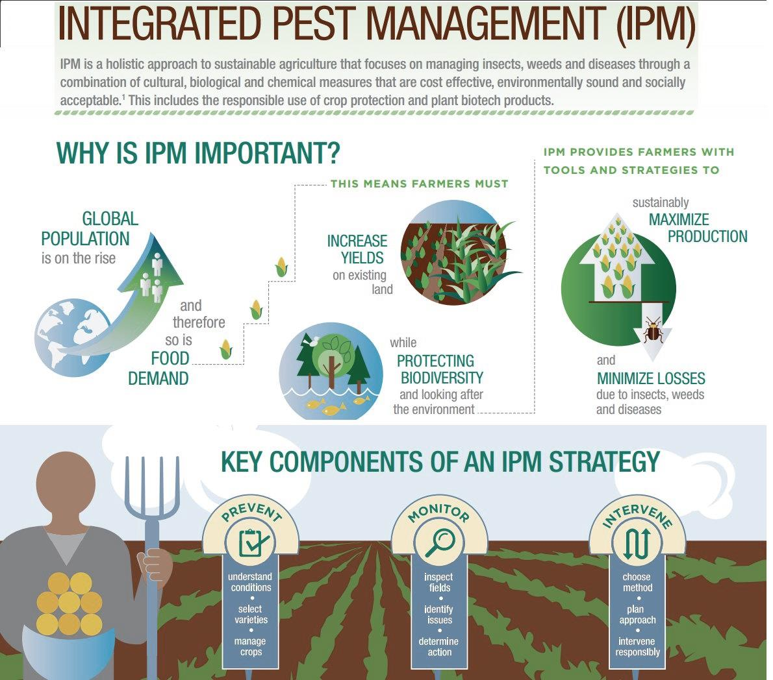
http://www.croplifeasia.org/wp-content/uploads/2018/05/10-JPG-Integrated-Pest-Management-IPM-731x1024.jpg

___________________________________________________________________________
7.1.
What is pest monitoring?
i) scouting for the pest present in the area.
ii)How many and how much damage they are causing
iii) watching for pesticide to kill the pest
iv)Identifying the pest’s predator
- i&ii
- ii&iv
- i& iii
- ii&iv

7.2
When same pesticide is used again and again in the same place against the same pest , the population of pest will increase every time than the original pest population. Give reason.
______________________________________________________________________________________________________________________________________________________________________________________________________________________________________________________________________________________________________________________________________________________________________________________________________________________________________________

________________________________________________________________________________
7.3.
How can you justify that pesticide help to conserve the environment?
_________________________________________________________________________________________________________________________________________________________________________________________________________________________________________________

_____________________________________________________________________________
7.4.
In set A there are two agricultural farms side by side. Both are using the IPM. In another set B there are two farms where one farm is using IPM and the other is using traditional pest control method by chemical pesticide. Which set of farmers will be more economically viable? Put a tick against the correct option.
SET A
SET B

7.5.
What are the physical factors that should considered before spraying the pesticide in an agricultural field to make it cost viable?
____________________________________________________________________________________________________________________________________________________________________

KENDRIYA VIDYALAYA SANGATHAN, KOLKATA REGION
CCT PRACTICE ITEMS FOR SCIENTIFIC LITERACY
Template -2
Domain: Scientific Literacy | Theme: IMPROVEMENT IN FOOD RESOURCES  CONCEPT- SIGNIFICANCE OF LOCAL AND CROSS BREED | CLASS: IX  Expected time: 15minutes  Total Credit:10
Description of Item: Text | Learning Outcome: ABLE TO EVALUATE THE SIGNIFICANCE OF INTEGRATED PEST MANAGEMENT  ABLE TO TRANSLATE THE INFORMATION IN OTHER FORM  ABLE TO SEE RELATIONSHIP BETWEEN CAUSE AND EFFECT

Scientific Literacy
QUESTION NO. 7.1
FRAMEWORK | CHARACTERISTICS
COMPETENCY | Explain the phenomena scientifically
KNOWLEDGE SYSTEM | Content knowledge
CONTEXT | Global
COGNITIVE DEMAND | Medium
ITEM FORMAT | C MCQ
PROFICIENCY LEVEL | 2
QUESTION NO.7. 2

FRAMEWORK | CHARACTERISTICS
COMPETENCY | Explain the phenomena scientifically
KNOWLEDGE SYSTEM | Procedural knowledge
CONTEXT | Global
COGNITIVE DEMAND | Medium
ITEM FORMAT | Closed constructed type
PROFICIENCY LEVEL | 3
QUESTION NO. 7.3

FRAMEWORK | CHARACTERISTICS
COMPETENCY | Explain the phenomena scientifically
KNOWLEDGE SYSTEM | Epistemic knowledge
CONTEXT | Global
COGNITIVE DEMAND | Medium
ITEM FORMAT | Closed constructed
PROFICIENCY LEVEL | 3

QUESTION NO. 7.4

FRAMEWORK | CHARACTERISTICS
COMPETENCY | Explain the phenomena scientifically
KNOWLEDGE SYSTEM | Procedural knowledge
CONTEXT | Global
COGNITIVE DEMAND | Medium
ITEM FORMAT | Closed constructed
PROFICIENCY LEVEL | 4

QUESTION NO. 7.5
FRAMEWORK | CHARACTERISTICS
COMPETENCY | Explain the phenomena scientifically
KNOWLEDGE SYSTEM | Procedural knowledge
CONTEXT | Global
COGNITIVE DEMAND | Low
ITEM FORMAT | Closed constructed
PROFICIENCY LEVEL | 3
Credit Pattern:
Full Credit: 2
Partial Credit:1
Nil Credit:0

Description of Answer Key and Credits:
7.1
Ans. full credit- a) I &ii (2)
No Credit: Any other answer (0)
7.2. Full credit : Every time when the pesticide applied some pest are eliminated from the actual population. Rest of the population is able to grow resistance against the chemical of the pesticide. This population is able to resist a particular concentration of pesticide. Next time resistant variety of pest will have all optimum condition or growth and reproduction. (2)
Partial Credit: Growth of resistance but not mentioned the concentration.(1)
No credit : Any other answer(0)

7.3.

FULL CREDIT: They enable farmers to produce more crops per unit area with less tillage, thus reducing deforestation, conserving natural resources and curbing soil erosion. Pesticides are also critical for the control of invasive species and noxious weeds.(2)
Partial Credit: If any one point is lacking.(1)
Nil Credit: Any other point.(0)
7.4.
FULL CREDIT: YES (2)
NIL CREDIT: YES (0)
7.5
FULL CREDIT: Wind speed and direction, moisture, temperature, droplet size(2)
Partial Credit: Any one point is not written(1)
NIL CREDIT: No points (0)

Name of the Teacher: Mr. SABITABRATA MANDAL
Designation: PGT(BIO)
Email: sabitabratama@gmail.com
Phone No.: 9433172799
Name of the Vidyalaya: K.V. Ballygunge
KVS Region: Kolkata

KENDRIYA VIDYALAYA SANGTHAN
REGIONAL OFFICE KOLKATA
PRACTICE ITEMS FOR SCIENTIFIC LITERACY

Domain: SCIENTIFIC LITERACY | Topic: IMPROVEMENT IN FOOD RESOURCES | Class: IX

Items Prepared by Mr.Sabitabrata Mandal.PGT(BIO) KV Ballygunge, Kolkata Region
INTERCROPPING AND CROP ROTATION FOR SUSTAINABILITY
A
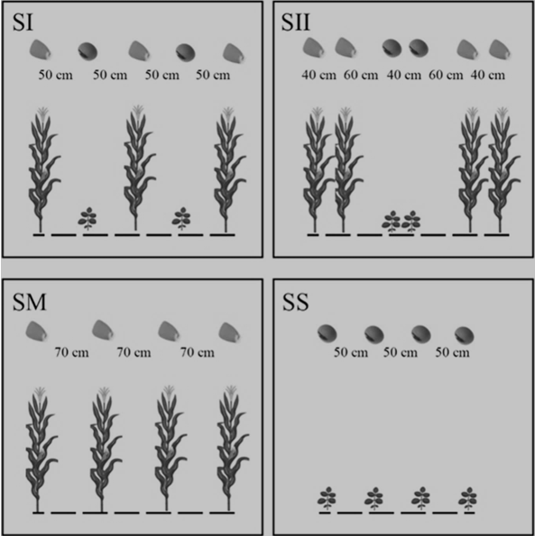
https://www.nature.com/articles/s41598-019-41364-1
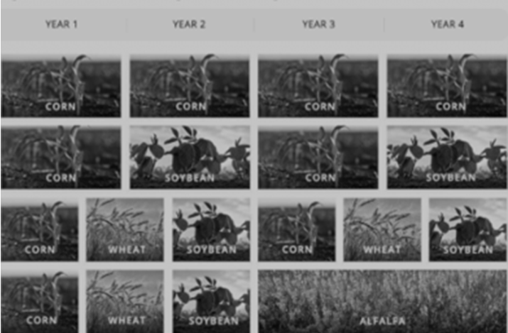
B

https://alaskamastergardener.community.uaf.edu/wp-content/uploads/sites/541/2019/12/crop-rotation.png

__________________________________________________________________________________
8.1.a

In fig B the second row is the best method to conserve the quality of soil among all the four rows on long term basis.
YES
NO

8.1.b
Justify your answer.

___________________________________________________________________________
8.2.
In the fig.A Which among the following has the best land use ratio?
a) SI
b)SII
c) SM
d) SS
_________________________________________________________________________________
8.3,a
What is aim of this experimental model shown in the fig A?
____________________________________________________________________________
_______________________________________________________________________________
8.3.b What should be the two most important structural criteria of plants to be considered for inter cropping?
___________________________________________________________________________________________________________________________________________________________________

_________________________________________________________________________

8.4 Why is SII more sustainable than SI?
______________________________________________________________________________________________________________________________________________________________________________________________________________________________________________________

__________________________________________________________________________________

8.5. Why is fourth row of fig B also represent sustainable agriculture?
_______________________________________________________________________________________________________________________________________________________________________________________________________________________________________________________________________________________________________________________________________

KENDRIYA VIDYALAYA SANGATHAN, KOLKATA REGION
CCT PRACTICE ITEMS FOR SCIENTIFIC LITERACY
Template -3
Domain: Scientific Literacy | Theme: IMPROVEMENT IN FOOD RESOURCES  CONCEPT- INTERCROPPING AND CROP ROTATION FOR SUSTAINABILITY | CLASS: IX  Expected time: 15minutes  Total Credit:10
Description of Item: Text | Learning Outcome: ABLE TO EVALUATE THE SIGNIFICANCE OF INTERCROPPING AND CROP ROTATION  ABLE TO TRANSLATE THE INFORMATION IN OTHER FORM  ABLE TO SEE RELATIONSHIP BETWEEN CAUSE AND EFFECT

Scientific Literacy

QUESTION NO. 8.1
FRAMEWORK | CHARACTERISTICS
COMPETENCY | Explain the phenomena scientifically
KNOWLEDGE SYSTEM | Content knowledge
CONTEXT | Global
COGNITIVE DEMAND | Low
ITEM FORMAT | Closed Construct
PROFICIENCY LEVEL | 2

QUESTION NO.8. 2
FRAMEWORK | CHARACTERISTICS
COMPETENCY | Explain the phenomena scientifically
KNOWLEDGE SYSTEM | Content knowledge
CONTEXT | Global
COGNITIVE DEMAND | LOW
ITEM FORMAT | MCQ
PROFICIENCY LEVEL | 2

QUESTION NO. 8.3
FRAMEWORK | CHARACTERISTICS
COMPETENCY | Explain the phenomena scientifically
KNOWLEDGE SYSTEM | Content
CONTEXT | Global
COGNITIVE DEMAND | Low
ITEM FORMAT | Closed constructed
PROFICIENCY LEVEL | 2

QUESTION NO. 8.4
FRAMEWORK | CHARACTERISTICS
COMPETENCY | Explain the phenomena scientifically
KNOWLEDGE SYSTEM | Epistemic knowledge
CONTEXT | Global
COGNITIVE DEMAND | Low
ITEM FORMAT | open constructed
PROFICIENCY LEVEL | 2

QUESTION NO. 8.5
FRAMEWORK | CHARACTERISTICS
COMPETENCY | Explain the phenomena scientifically
KNOWLEDGE SYSTEM | Procedural knowledge
CONTEXT | Global
COGNITIVE DEMAND | low
ITEM FORMAT | Closed constructed
PROFICIENCY LEVEL | 2

Credit Pattern:
Full Credit: 2
Partial Credit:1
Nil Credit:0

Description of Answer Key and Credits:
8.1.a
Ans. full credit- NO (1)
No Credit: Any other answer (0)
8.1.b.
Ans.full credit Fourth row is the best because it is having more scope for revival of macronutrients and microbial activity(1)
No credit : Any other answer(0)
8.2
FULL CREDIT: B(2)
Partial Credit: A1)
Nil Credit: Any other option.(0)
8,3.a
FULL CREDIT: Effect of planting patterns on yield on crop production (1)
NIL CREDIT: Any other answer (0)
3.3.b
FULL CREDIT: Height of the plant and length of the root (1)
Partial Credit: Any one points(0.5)
NIL CREDIT: No points (0)
8.4
Ans. FULL CREDIT: Intercropping is a sustainable practice that can improve resource-use efficiency, such as nutrients and water, allowing low input agricultural practices along with less effect of pest and weed. SII is more sustainable because it is more intensive so more economic viable.
PARTIAL CREDIT: Any part is missing. (1)
NO CREDIT: Both the points are missing.(0)
8.5 . FULL CREDIT: crop rotation reduces the costs of production by reducing or avoiding the use of external inputs, especially fertilisers and pesticides so it is sustainable.(1)

Name of the Teacher: Mr. SABITABRATA MANDAL
Designation: PGT(BIO)
Email: sabitabratama@gmail.com
Phone No.: 9433172799
Name of the Vidyalaya: K.V. Ballygunge
KVS Region: Kolkata

KENDRIYA VIDYALAYA SANGTHAN
REGIONAL OFFICE KOLKATA
PRACTICE ITEMS FOR SCIENTIFIC LITERACY

Domain: SCIENTIFIC LITERACY | Topic: IMPROVEMENT IN FOOD RESOURCES | Class: IX

Items Prepared by Mr.Sabitabrata Mandal.PGT(BIO) KV Ballygunge, Kolkata Region
GENETICALLY MODIFIED PLANT A BOON/ CURSE
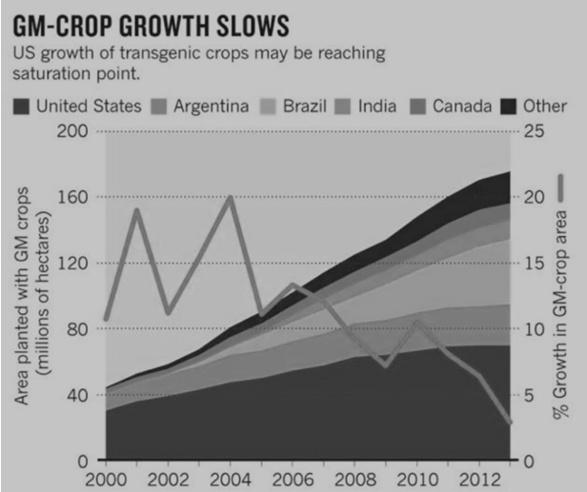
https://www.nature.com/news/seven-days-14-20-february-2014-1.14729#/trend
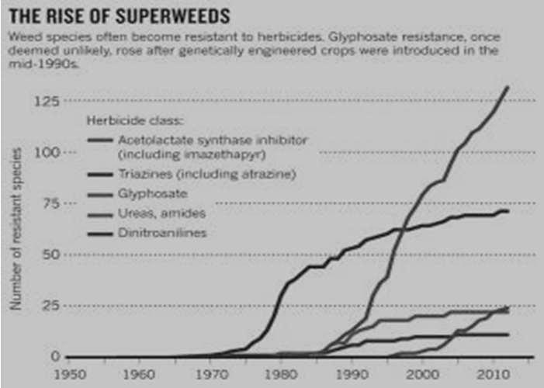
Whitty, C., Jones, M., Tollervey, A. et al. Africa and Asia need a rational debate on GM crops. Nature 497, 31–33 (2013). https://doi.org/10.1038/497031a
--------------------------------------------------------------------------------------------------------------------------------------
9.1.
As a result of genetically modified crops, weedicide use on farms has:
a. Gone up dramatically.
b. Gone down dramatically.
c. Gone up on some but no change on others.
d. Gone down on some crops but there is little or no change on others.
e. Not changed.

9.2.
Will insects develop resistance to the toxins produced in Bt corn?
a. It is impossible for insects to develop resistance to Bt corn.
b. It is unlikely that insects will develop resistance to Bt corn.
c. Under certain conditions insects may develop resistance to Bt corn.
d. It is almost certain that insects will develop resistance to Bt corn.
e. Insects are already resistant to the toxins produced in Bt corn

9.3
If we make plants that survive in regions where they normally wouldn't survive, such as very cold regions, could this cause unexpected ecological changes?
………………………………………………………………………………………………………………………………………………………………………………………………………………………………………………………………………………………………………………………………………………………………………………………………………………………………………………………………………………………
_________________________________________________________________________________
9.4.
Are foods derived from genetically modified crops nutritionally superior? Support your answer with argument
Answer: …………………………………………………………………………………………………………………………………………………………………………………………………………………………………………………………………………………………………………………………………………………………………………………………………………………………………………………………………………………………………………………………………………………………………………………………………………………………………………………..________________________________________________________________________________
9.5.
What are the main issues of concern for human health with reference to GM crop food?
……………………………………………………………………………………………………………………………………………………………………………………………………………………………………………………………………………………………………………………………………………………………………………………………………………………………………………………………………………………….
__________________________________________________________________________________

KENDRIYA VIDYALAYA SANGATHAN, KOLKATA REGION
CCT PRACTICE ITEMS FOR SCIENTIFIC LITERACY
Template -4
Domain: Scientific Literacy | Theme: IMPROVEMENT IN FOOD RESOURCES  CONCEPT- GMO A BOON OR CURSE | CLASS: VIII  Expected time: 10minutes  Total Credit:10
Description of Item: Text | Learning Outcome: ABLE TO EVALUATE THE SIGNIFICANCE OF GMO  ABLE TO TRANSLATE THE INFORMATION IN OTHER FORM  ABLE TO SEE RELATIONSHIP BETWEEN CAUSE AND EFFECT

Scientific Literacy

QUESTION NO. 9.1
FRAMEWORK | CHARACTERISTICS
COMPETENCY | Explain the phenomena scientifically
KNOWLEDGE SYSTEM | Content knowledge
CONTEXT | GLOBAL
COGNITIVE DEMAND | MEDIUM
ITEM FORMAT | MCQ
PROFICIENCY LEVEL | 3

QUESTION NO.9. 2
FRAMEWORK | CHARACTERISTICS
COMPETENCY | Interpret data and evidence scientifically
KNOWLEDGE SYSTEM | Content knowledge
CONTEXT | GLOBAL
COGNITIVE DEMAND | MEDIUM
ITEM FORMAT | MCQ
PROFICIENCY LEVEL | 3

QUESTION NO. 9.3
FRAMEWORK | CHARACTERISTICS
COMPETENCY | Evaluate and design scientific inquiry
KNOWLEDGE SYSTEM | Epistemic knowledge
CONTEXT | Local
COGNITIVE DEMAND | Medium
ITEM FORMAT | Open constructed
PROFICIENCY LEVEL | 3

QUESTION NO. 9.4
FRAMEWORK | CHARACTERISTICS
COMPETENCY | Evaluate and Design scientific enquiry
KNOWLEDGE SYSTEM | Epistemic knowledge
CONTEXT | Global
COGNITIVE DEMAND | High
ITEM FORMAT | open constructed
PROFICIENCY LEVEL | 5

QUESTION NO. 9.5
FRAMEWORK | CHARACTERISTICS
COMPETENCY | Explain the phenomena scientifically
KNOWLEDGE SYSTEM | Content knowledge
CONTEXT | Global
COGNITIVE DEMAND | Medium
ITEM FORMAT | Closed constructed
PROFICIENCY LEVEL | 3

Credit Pattern:
Full Credit: 2
Partial Credit:1
Nil Credit:0

Description of Answer Key and Credits:
9.1
FULL CREDIT: a. Gone up dramatically.(2)
NIL CREDIT: Any other option(0)
9.2
FULL Credited. It is almost certain that insects will develop resistance to Bt corn.(2)
NIL CREDIT: Any other option(0)
9.3
FULL CREDIT: The plant may become competitive to the local vegetation under certain conditions. It is possible that a crop might invade the surrounding ecosystem. (2)
PARTIAL CREDIT: Plant may grow is surrounding suits. (1)
Nil Credit: Any other answer.(0)
9.4
FULL CREDIT: No. They are neither better nor worse than foods from conventional crops. Most of the genetically modified crops currently available are designed to reduce farmers' production costs. In the future GM crops hold the promise of delivering foods that are nutritionally enhanced.(2)
Partial Credit: No. No argument is given(1)
Nil Credit: Any other answer(0)
9.5
FULL CREDIT: The three main issues debated are tendencies to provoke allergic reaction (allergenicity), gene transfer environmental impact and outcrossing.
PARTIAL CREDIT: Missing any two points(1)
Nil Credit: Not mentioning any point(0)

Name of the Teacher: Mr. SABITABRATA MANDAL
Designation: PGT(BIO)
Email: sabitabratama@gmail.com
Phone No.: 9433172799
Name of the Vidyalaya: K.V. Ballygunge
KVS Region: Kolkata

KENDRIYA VIDYALAYA SANGTHAN
REGIONAL OFFICE KOLKATA
PRACTICE ITEMS FOR SCIENTIFIC LITERACY

Domain: SCIENTIFIC LITERACY | Topic: IMPROVEMENT IN FOOD RESOURCES | Class: IX

Items Prepared by Mr.Sabitabrata Mandal.PGT(BIO) KV Ballygunge, Kolkata Region

Topic: Fertilizer overuse eating away Punjab’s soil nutrients
“The current agricultural yield against the use of one kg of NPK has come down to 10 kg from the earlier 50 kg during the initial years of the Green Revolution (around 1970-71),” says the committee, which studied adverse circumstances of chemical-based farming in India and its cascading effect on soil health, environment and percolation of toxic chemicals in food chain and water bodies.
The findings indicate farmers in order to increase the yields are pumping in more nitrogen and phosphorous into the soil, leading to its further degradation.

In light of serious impacts of chemical fertilisers of soil biodiversity and human health, the panel (Estimates Committee of the Lok Sabha) headed by senior BJP leader Murli Manohar Joshi, has made several recommendations, including building a comprehensive national policy on organic farming. It has also recommended weeding out fake organic products along with stringent punishment for those pushing non-organic produce as organic.
(https://www.tribuneindia.com/news/archive/nation/fertiliser-overuse-eating-away-punjab-soil-nutrients-123774 )

10.1.
We add manure in the above-mentioned situation as soil amendments because________
a)Manure contain higher concentrations of plant nutrients than most fertilizers.
b)Nitrogen contained in manure is less environmentally harmful than nitrogen contained in fertilizer
c)Manure supply organic matter as well as plant nutrients
d)Ammonia gas is readily volatilized from them
e)Both answers 2 and 3

10.2 Find out the correct sentence about manure
(i) Manure contains large quantities of organic matter and small quantities of nutrients.
(ii) It increases the water holding capacity of sandy soil.
(iii) It helps in draining out of excess of water from clayey soil.
(iv) Its excessive use pollutes environment because it is made of animal excretory waste.
(a) (i) and (iii)
(b) (i) (ii)and (iii)
(c) (ii) and (iii)
(d) (iii) and (iv)
………………………………………………………………………………………

________________________________________________________________________________

10.3.
When are we adding fertilizer then why the soil is becoming nutrient deficient in general?
………………………………………………………………………………………………………………………………………………………………………………………………………………………………………………………………………………………………………………………………………………………………………………………………………………………………………………………………………………………………………………………………………………………………………………………………………………………………………………….

__________________________________________________________________________________

10.4. A rich farmer has burnt the crop waste in his field. Why the burning of crop waste is needed for him?
…………………………………………………………………………………………………………………………………………………………………………………………………………………………………………………………………………………………………………………………………………………………………………………………………………………………………………………………………………………………………………………………………………………………………..

10.5. Why vermicompost is better than compost for crops?
………………………………………………………………………………………………………………………………………………………………………………………………………………………………………………………………………………………………………………………………………………………………………………………………………………………………………………………………………………………………………………………………………………………………………………………..

__________________________________________________________________________________

KENDRIYA VIDYALAYA SANGATHAN, KOLKATA REGION
CCT PRACTICE ITEMS FOR SCIENTIFIC LITERACY
Template -5
Domain: Scientific Literacy | Theme: IMPROVEMENT IN FOOD RESOURCES  CONCEPT- COMPOSITE SOIL MANAGEMENT | CLASS: VIII  Expected time: 15minutes  Total Credit:10
Description of Item: Text | Learning Outcome: ABLE TO EVALUATE THE SIGNIFICANCE MISUSE OF FERTILIZER  ABLE TO TRANSLATE THE INFORMATION IN OTHER FORM  ABLE TO SEE RELATIONSHIP BETWEEN CAUSE AND EFFECT

Scientific Literacy

QUESTION NO. 10.1
FRAMEWORK | CHARACTERISTICS
COMPETENCY | Explain the phenomena scientifically
KNOWLEDGE SYSTEM | Content knowledge
CONTEXT | Local
COGNITIVE DEMAND | Low
ITEM FORMAT | MCQ
PROFICIENCY LEVEL | 2

QUESTION NO.10. 2
FRAMEWORK | CHARACTERISTICS
COMPETENCY | Interpret data and evidence scientifically
KNOWLEDGE SYSTEM | Content knowledge
CONTEXT | LOCAL
COGNITIVE DEMAND | LOW
ITEM FORMAT | C MCQ
PROFICIENCY LEVEL | 2

QUESTION NO. 10.3
FRAMEWORK | CHARACTERISTICS
COMPETENCY | Evaluate and design scientific inquiry
KNOWLEDGE SYSTEM | Epistemic knowledge
CONTEXT | Local
COGNITIVE DEMAND | Medium
ITEM FORMAT | Open constructed
PROFICIENCY LEVEL | 3

QUESTION NO. 10.4
FRAMEWORK | CHARACTERISTICS
COMPETENCY | Evaluate and Design scientific enquiry
KNOWLEDGE SYSTEM | Epistemic knowledge
CONTEXT | Global
COGNITIVE DEMAND | High
ITEM FORMAT | open constructed
PROFICIENCY LEVEL | 5

QUESTION NO. 10.5
FRAMEWORK | CHARACTERISTICS
COMPETENCY | Explain the phenomena scientifically
KNOWLEDGE SYSTEM | Procedural knowledge
CONTEXT | Global
COGNITIVE DEMAND | Medium
ITEM FORMAT | Closed constructed
PROFICIENCY LEVEL | 3

Credit Pattern:
Full Credit: 2
Partial Credit:1
Nil Credit:0

Description of Answer Key and Credits:
10.1
FULL CREDIT: E(2)
NIL CREDIT: ANY OTHER ANSWER.(0)
10.2Sol. (b)
FULL CREDIT: b(2)
NIL CREDIT: ANY OTHER ANSWER.(0)
10.3
FULL CREDIT: The crop removes/ absorbs large quantity of plant nutrients from soil, particularly the removal of NPK nutrients at the present level of crop production whereas the annual addition is less to the soil resulting in depletion of the nutrient reserve of soil.
PARTIAL CREDIT: MENTIONS crop absorbs(1)
NIL CREDIT: Not able to show the relationship between removal and addition of NPK(0)
10.4
FULL CREDIT: Ans . Combine harvesters leave behind rice stubble, which prevents machines from sowing wheat seeds. With as little as 10 days between rice harvesting season and the sowing of wheat, farmers often turn to stubble burning to quickly remove the remaining rice crop residue.(2)
NIL CREDIT: ANY OTHER ANSWER(1)
10.5
FULL CREDIT: Ans. Vermicompost has more nutrients, Rich in nitrates, plant growth regulators, more microbial diversity than the compost. It can improve different physical characteristics of soil thus improving the soil health.(2)
NIL CREDIT: ANY OTHER ANSWER (0)

Name of the Teacher: Mr. SABITABRATA MANDAL
Designation: PGT(BIO)
Email: sabitabratama@gmail.com
Phone No.: 9433172799
Name of the Vidyalaya: K.V. Ballygunge
KVS Region: Kolkata

