CRITICAL AND CREATIVE THINKING TEST ITEMS

CLASS IX SUB: SCIENCE CHAPTER-13 : WHY DO WE FALL ILL?
INDEX
S.No: | Topic
1 | Visible Vs Silent Coronaries
2 | The Invisible ‘Guns’
3 | Swatchh Bharat Mission-A Step towards healthy India
4 | Transmission of Infectious Diseases
5 | COVID-19-Vaccine-the wait continues
6 | Reading Blood Report
7 | Health is Wealth
8 | Typhoid
9 | Obesity and over weight
10 | CAM Approaches in treatment

TEST ITEM 1
Visible Vs Silent Coronaries
In 1949, a study of heart disease included 5,137 adults: 2,292 men and 2,845 women.
All the individuals were 49 to 70 years of age, and none showed any signs of coronary artery disease. After 14-16 years of careful follow-up, it was found that:
151 men and 37 women showed evidence of coronary artery disease that would account for a heart attack.
102 men and 18 women died of coronary artery disease before they reached the age of 65.
58 percent of the men and 39 percent of the women died within one hour of having a heart attack.
For both men and women, sudden death was more likely if they were under age 55 at the time of the attack.
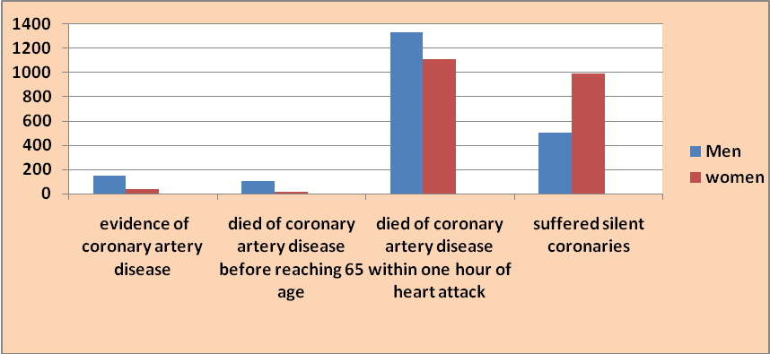
Question 1.
Not all heart attacks produce symptoms. A considerable number of men and women had a myocardial infarction (heart muscle damage) without knowing it. Of those who suffered such “silent coronaries”; 22 percent of the men and 35 percent of the women did not know muscle damage had occurred.
As explained in the study, a person who has a “silent coronary”
  - is unaware of any heart attack symptoms
  - does not scream in pain while having a heart attack
  - shows no evidence of heart muscle damage
  - always dies of a myocardial infarction

FRAMEWORK | CHARACTERISTICS
Competency | Explain phenomenon scientifically
Knowledge-system | Living system
Context | Social
Cognitive demand | Easy
Item format | Simple MCQ type
Proficiency level | 1

√ | Text
 | Image
 | Table
 | Graph
 | Map
 | Poem

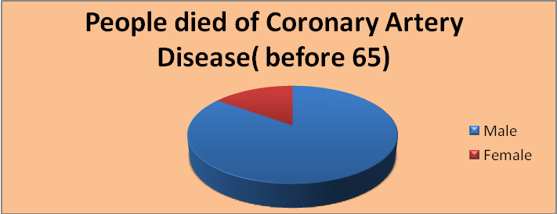

Question 2.
Based on the results of this experiment, of the people who died of coronary artery disease before age 65
- 18 percent were women
- 20 percent were women
- 85 percent were men
- 102 percent were men

√ | Text
√ | Image
 | Table
√ | Graph
 | Map
 | Poem

FRAMEWORK | CHARACTERISTICS
Competency | Interpret data and evidence scientifically
Knowledge-system | Living system
Context | Social
Cognitive demand | Medium
Item format | Complex MCQ type
Proficiency level | 3

Question 3.
On the basis of results of the study given above, few statements are enlisted below.
Are these statements in accordance with the graph given?

Encircle ‘ Yes’ or ‘No’ for each statement.
Statement | Yes or No
Chances of death within one hour of a heart attack are greater for men than women.
Chances of death from coronary artery disease are less for men than women.
Evidence of coronary artery disease is equal among men and women.
Sudden death is more likely for both men and women if they are under age 55 at the time of the attack.

FRAMEWORK | CHARACTERISTICS
Competency | Recognizing scientific enquiry and identifying Evidences
Knowledge-system | Living system
Context | Social
Cognitive demand | Medium
Item format | Binary choice type
Proficiency level | 3

√ | Text
 | Image
√ | Table
 | Graph
 | Map
 | Poem
Questn 4.
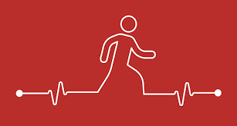
Give one reason why people suffering from coronary heart diseases should be advised to go for walks and do simple exercises?

__________________________________________________________________________
_____________________________________________________________________________

FRAMEWORK | CHARACTERISTICS
Competency | Explain phenomenon scientifically
Knowledge-system | Living system
Context | Personal
Cognitive demand | Medium
Item format | Short response type
Proficiency level | 3

√ | Text
√ | Image
 | Table
 | Graph
 | Map
 | Poem

CREDIT PATTERN ITEM - 1
Question 1
Full Credit: c) shows no evidence of heart muscle damage
No credit: wrong or missing

Question 2
Full Credit: c) 85% were men
No credit: wrong or missing

Question 3
Full Credit: yes, no, no ,yes in this order
Partial credit: two correct answers
No credit: wrong or missing

Question 4
Full Credit: as it will help the heart get stronger and more efficient, also there will be proper blood supply to the heart
Partial credit: one point or half correct answer
No credit: wrong or missing

TEST ITEM NO 2
The Invisible "Guns"
For a long time, Native Americans had lived completely isolated from the rest of the world. They had never been exposed to diseases such as measles, smallpox, and influenza, so they had no resistance to them. They had no vaccines and no medicines to fight these diseases. A Native American might visit a trading post and shake hands with a European who had one of these diseases. The Native American, however, would return to his tribe, fall ill, and, in all likelihood, infect other members of his tribe.
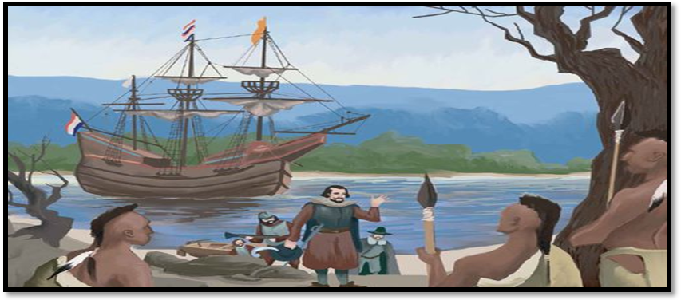
Once a disease was introduced into a Native American village, people began dying. Sometimes 50 to 90 percent of the people would die. Worse, all the people would get sick at the same time.

Question 1
Smallpox hit Native Americans in the Northeast in 1633, causing a 95 percent death rate among some villages along the Connecticut River. In 1620, the Huron numbered around twenty thousand people. By 1640, disease had slashed that number in half.
Because there were no cases of small pox in Native America before as they were isolated from rest of the world, what would be considered an outbreak?
- 1 case
- 5 cases
- 50 cases
- 300 cases

FRAMEWORK | CHARACTERISTICS
Competency | Explain phenomenon scientifically
Knowledge-system | Living system
Context | Global
Cognitive demand | Easy
Item format | Simple MCQ type
Proficiency level | 2

√ | Text
 | Image
 | Table
 | Graph
 | Map
 | Poem

Question 2

In Asia, a technique known as variolation involved deliberately infecting a person by blowing dried Smallpox scabs up their nose. Those who received this treatment contracted a mild form of the disease, developing a life time immunity.
It means the type of microorganisms that caused the disease does not usually make them sick again.
What is the reason for this?

- The body has killed all microorganisms that may cause the same kind of disease.
- The body has made antibodies that kill this type of microorganisms before they multiply.
- The red blood cells kill all microorganisms that may cause the same kind of disease.
- The red blood cells capture and get rid of this type of microorganisms from the body.

FRAMEWORK | CHARACTERISTICS
Competency | Explain phenomenon scientifically
Knowledge-system | Living system
Context | Personal
Cognitive demand | Medium
Item format | Complex MCQtype
Proficiency level | 3

√ | Text
 | Image
 | Table
 | Graph
 | Map
 | Poem

Question 3
In the given graph, a sudden decline can be seen in the number of deaths over the
period of time from 1702 to 1920.
Give suitable reason behind the same and correlate it with the type of treatment
involved.
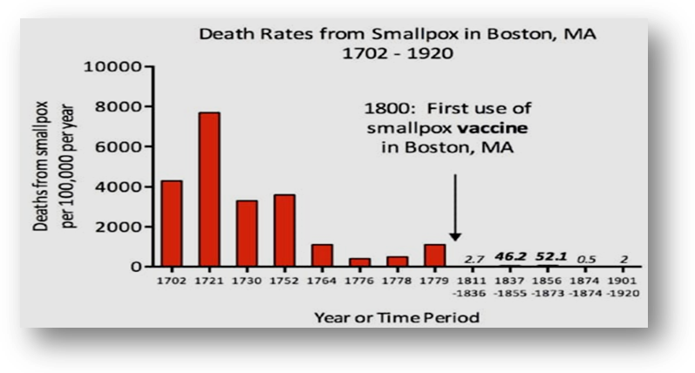
__________________________________________________________________
___________________________________________________________________

FRAMEWORK | CHARACTERISTICS
Competency | Interpret data and evidence scientifically
Knowledge-system | Living system
Context | Global
Cognitive demand | Medium
Item format | Closed constructed response type
Proficiency level | 3

√ | Text
 | Image
 | Table
√ | Graph
 | Map
 | Poem

Question 4
Europeans used this disease as a weapon against Native Americans. During a siege of a
British fort in 1763, the fort’s commander invited some of the Americans to a truce in
order to talk peace. As a greeting, the commander presented them with a handkerchief
and two blankets that he knew were infected with smallpox.
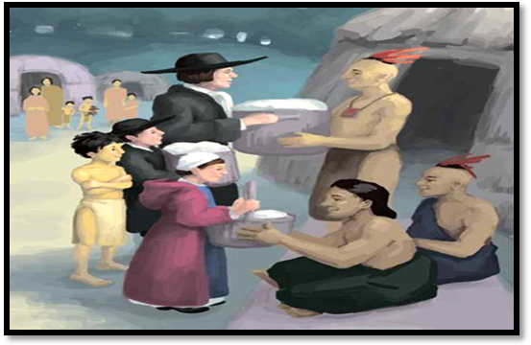
During the next few months, hundreds of Americans in the Ohio Valley died.
Give suitable reason behind the death of Americans.
___________________________________________________________________
____________________________________________________________________

FRAMEWORK | CHARACTERISTICS
Competency | Explain phenomenon scientifically
Knowledge-system | Living system
Context | Personal
Cognitive demand | Medium
Item format | Short response type
Proficiency level | 3

√ | Text
√ | Image
 | Table
 | Graph
 | Map
 | Poem

CREDIT PATTERN ITEM - 2
Question 1
Full Credit: a) 1 case as even one confirmed case would be considered a public health
No credit: wrong or missing

Question 2
Full Credit: – b) the body has made antibodies that kill this type of bacteria before they multiply.
No credit: wrong or missing

Question 3
Full Credit: because vaccine for smallpox was introduced at the end of 18th century to combat the
disease due to which people became immune to it by developing antibodies.
Partial credit: Partial correct answer
No credit: wrong or missing

Question 4
Full Credit: Americans died due to the infectious disease small pox which was spread because of the
handkerchief and blankets carrying virus.
Partial credit: partial correct answer
No credit: wrong or missing

TEST ITEM 3
SWATCHH BHARAT MISSION-A STEP TOWARDS HEALTHY INDIA
To accelerate the efforts to achieve universal sanitation coverage and to put the focus on sanitation, the Prime Minister of India had launched the Swachh Bharat Mission on 2nd October 2014. Under the mission, all villages, Gram Panchayats, Districts, States and Union Territories in India declared themselves "open-defecation free" (ODF) by 2 October 2019, the 150th birth anniversary of Mahatma Gandhi, by constructing over 100 million toilets in rural India.
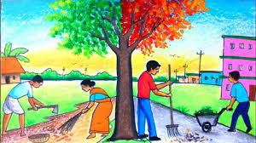
To ensure that the open defecation free Behaviour are sustained, no one is left behind, and that solid and liquid waste management facilities are accessible, the Mission is moving towards the next Phase II of SBMG i.e. ODF-Plus. ODF Plus activities under Phase II of Swachh Bharat Mission (Grameen) will reinforce ODF behaviours and focus on providing interventions for the safe management of solid and liquid waste in villages
Question 1
Swachh bharat Mission Concept was developed with the inspiration of which Indian leader ?
- Rajiv Gandhi
- Mahatma Gandhi
- Sardar Vallabhai Patel
- Pd. Jawahar lal Nehru

FRAMEWORK | CHARACTERISTICS
Competency | Interpret data and evidence scientifically
Knowledge-system | Living system
Context | Social
Cognitive demand | Easy
Item format | Simple MCQ type
Proficiency level | 1

√ | Text
 | Image
 | Table
 | Graph
 | Map
 | Poem

Question 2

See the table given below regarding percentage of rural population not using toilets in 2015 and 2018 answer the questions that follows:
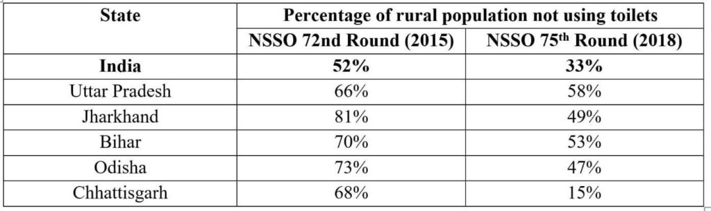
The following states are arranged in order of first, second and third with respect to non-usage of individual toilets in 2018. Choose the correct order
- Chhattisgarh, Orissa, Jharkhand
- Uttar Pradesh, Orissa, Bihar
- Uttar Pradesh, Bihar, Jharkhand
- Bihar , Uttar Pradesh, Jharkhand

FRAMEWORK | CHARACTERISTICS
Competency | Interpret data and evidence scientifically
Knowledge-system | Living system
Context | social
Cognitive demand | Medium
Item format | Complex MCQ type
Proficiency level | 3

√ | Text
 | Image
√ | Table
 | Graph
 | Map
 | Poem

Question 3
Statement 1: ODF Plus activities under Phase II of Swachh Bharat Mission (Grameen) will reinforce ODF behaviours and focus on providing interventions for the safe management of solid and liquid waste in villages
Justify the statement and give suitable reasons why solid and liquid waste management is necessary in villages.
_____________________________________________________________________________________
_____________________________________________________________________________________

FRAMEWORK | CHARACTERISTICS
Competency | Interpret data and evidence scientifically
Knowledge-system | Living system
Context | social
Cognitive demand | Medium
Item format | Open constructed response
Proficiency level | 3

√ | Text
 | Image
 | Table
 | Graph
 | Map
 | Poem

Question 4
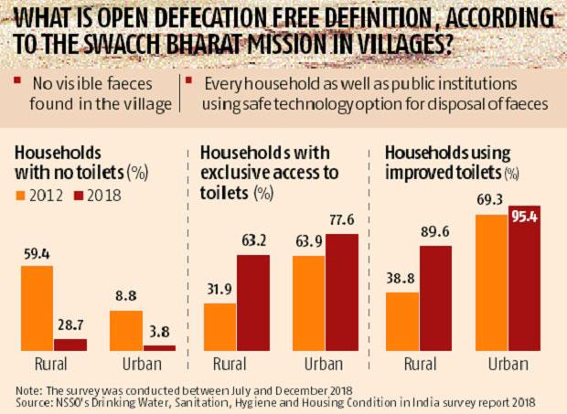
As per the survey data given on the newspaper article, why do you think there is drastic increase in the number of households using improved toilets in 2018 in rural areas?
__________________________________________________________________________________

FRAMEWORK | CHARACTERISTICS
Competency | Interpret data and evidence scientifically
Knowledge-system | Living system
Context | social
Cognitive demand | Medium
Item format | Short constructed response
Proficiency level | 3

√ | Text
√ | Image
 | Table
 | Graph
 | Map
 | Poem

CREDIT PATTERN ITEM - 3
Question 1
Full Credit: b) Mahatma Gandhi
No credit: wrong or missing

Question 2
Full Credit: c) Uttar Pradesh, Bihar, Jharkhand
No credit: wrong or missing

Question 3
Full Credit: To bring improvement in cleanliness, hygiene and the general quality of life in rural areas.
Partial credit: one point or half correct answer
No credit: wrong or missing

Question 4
Full Credit: There was drastic increase because ODF was declared by gram panchayats, villages , union territories under swatch bharat mission to make India free from open defecation.
Partial credit: one point or half correct answer
No credit: wrong or missing
TEST ITEM - 4
Transmission of infectious diseases

A century ago infectious diseases were by far the leading cause of death throughout the world. The graph below shows estimated survival among people born in the United Kingdom in mid-1800 .Approximately 70% died before the age of 25 , and the vast majority of deaths occurred among infants and children as a result of infectious disease. Perhaps more importantly infectious diseases remain the cause of premature death throughout the world because of a particularly heavy toll in infants and children. And it is estimated that 17 million people die prematurely each year and 9 million of these are children.

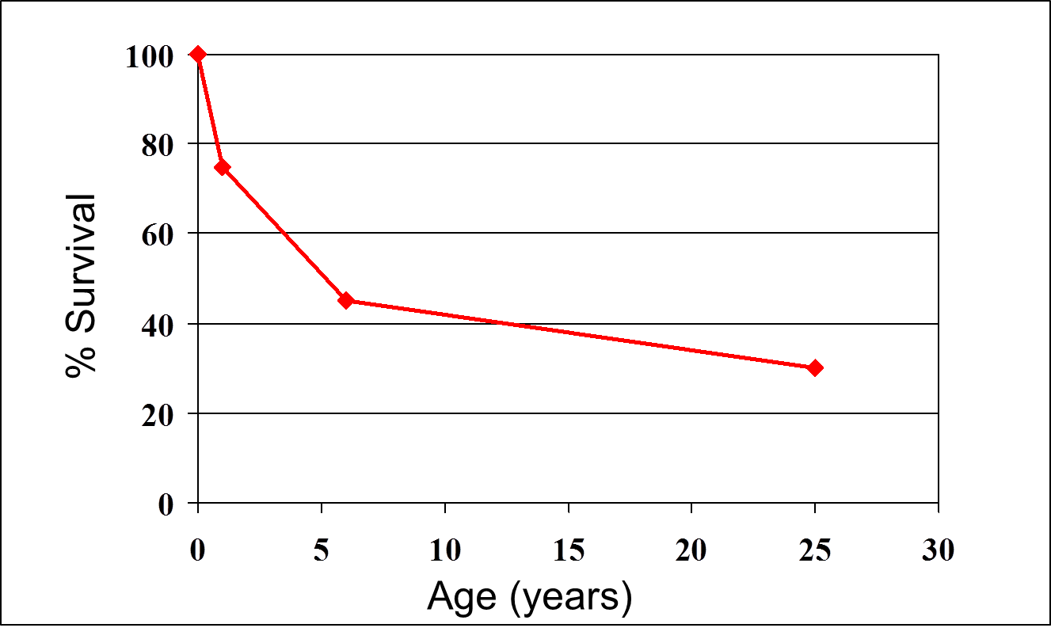

Public health measures have accounted for the vast majority of reductions in deaths from infectious disease through better sanitation ,cleaner water and the development of vaccines A key to the success has been an increasing refined understanding of the mechanism by which infectious agents are transmitted. An understanding of mechanism of transmission provides opportunities for simple effective measures that will prevent disease

Question 1
From the graph, calculate the percent survival of infectious diseases at the age of 12.
______________________________________________________________________________

FRAMEWORK | CHARACTERISTICS
Competency | Interpret data and evidence scientifically
Knowledge-system | Living system
Context | Global
Cognitive demand | Easy
Item format | Closed constructed response
Proficiency level | 1

√ | Text
 | Image
 | Table
√ | Graph
 | Map
 | Poem

Question 2
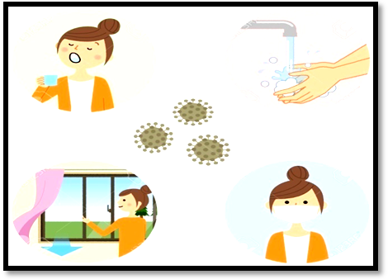
How can an infectious disease be prevented by better sanitation?

_____________________________________________________________________________
_____________________________________________________________________________

FRAMEWORK | CHARACTERISTICS
Competency | Explain phenomenon scientifically
Knowledge-system | Living system
Context | Global
Cognitive demand | Easy
Item format | Short response type
Proficiency level | 2

√ | Text
√ | Image
 | Table
 | Graph
 | Map
 | Poem

Question 3
What efforts can be put in to reduce the death rate from infectious diseases?
_____________________________________________________________________________
_____________________________________________________________________________

FRAMEWORK | CHARACTERISTICS
Competency | Explain phenomenon scientifically
Knowledge-system | Living system
Context | Global
Cognitive demand | Medium
Item format | Open constructed response type
Proficiency level | 3

√ | Text
 | Image
 | Table
 | Graph
 | Map

Question 4
The graph given below shows the estimates of new HIV infections by race ethnicity risk group and gender for the most affected US population 2009

From this graph find the difference in number of new HIV infections in Black heterosexual women and white Heterosexual women
a) 3,200
b) 1200
c) 3,600
d) 3,700

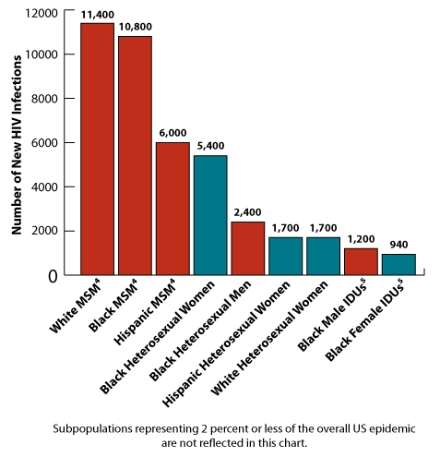

FRAMEWORK | CHARACTERISTICS
Competency | Interpret data and evidence scientifically
Knowledge-system | Living system
Context | Global
Cognitive demand | medium
Item format | Simple MCQ type
Proficiency level | 2

√ | Text
 | Image
 | Table
√ | Graph
 | Map
 | Poem

CREDIT PATTERN ITEM - 4
Question 1
Full Credit: 40%
No credit: wrong or missing

Question 2
Full Credit: Better sanitation , clean water and food and the development of vaccines
Partial credit: partially correct answer
No credit: missing

Question 3
Full Credit: washing hands frequently with soap and water, wearing mask, eating clean food and drinking clean water, social distancing
Partial credit: partially correct answer
No credit: wrong or missing

Question 4
Full Credit: d) 3,700

No credit: wrong or missing

TEST ITEM 5
COVID-19 vaccine- the wait continues
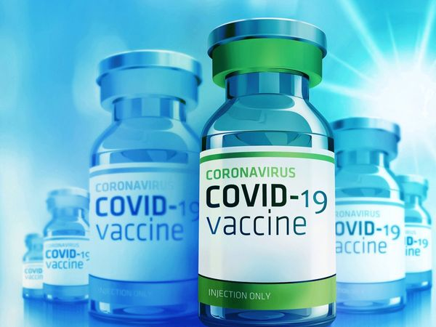
Scientists all over the world are diligently working to help us understand the novel coronavirus and the disease, COVID-19, it causes. Currently, there are no vaccines or specific antiviral medicines for COVID-19, although several vaccine candidates, monoclonal antibodies, and other therapies are being tested and developed globally. Experts believe a safe and effective vaccine for coronavirus or SARS-CoV-2 can help us return to some sense of normalcy.
As of 21 September, the draft landscape of COVID-19 candidate vaccines released by the World Health Organization (WHO) shows that at least 34 vaccines for COVID-19 are in clinical evaluation with several candidates already in the phase 3 clinical trials. In India, three vaccine candidates are in different stages of clinical trials. These include Bharat Biotech-ICMR's candidate, COVAXIN, which is India's first indigenously developed vaccine for COVID-19, Zydus cadila's ZyCoV-D, and the Oxford's candidate, dubbed Covishield in India, being tested and manufactured by the Pune-based Serum Institute.

Question 1
What kinds of diseases can people be vaccinated against?
- Inherited diseases like Thalassemia.
- Diseases that are caused by viruses, like Ebola, COVID, Rabies.
- Diseases from the malfunctioning of the body, like diabetes.
- Any sort of disease that has no cure like Cancer.

FRAMEWORK | CHARACTERISTICS
Competency | Evaluate and design scientific enquiry
Knowledge-system | Living system
Context | Global
Cognitive demand | Easy
Item format | Simple MCQ type
Proficiency level | 1

√ | Text
 | Image
 | Table
 | Graph
 | Map
 | Poem

Question 2
Statement 1-"Healthcare workers followed by the elderly and those with co-morbidities such as
diabetes should be the first recipients of Corona virus vaccines"

Statement 2- “healthcare, doctors, nurses and frontline healthcare professionals, as well as
scientists who are conducting clinical trials should be given the first shot”.

Which statement do you think is correct? Justify your answer.
__________________________________________________________________
___________________________________________________________________
___________________________________________________________________

FRAMEWORK | CHARACTERISTICS
Competency | Explain phenomenon scientifically
Knowledge-system | Living system
Context | Global
Cognitive demand | Medium
Item format | Open constructed response
Proficiency level | 3

√ | Text
 | Image
 | Table
 | Graph
 | Map
 | Poem

Question 3
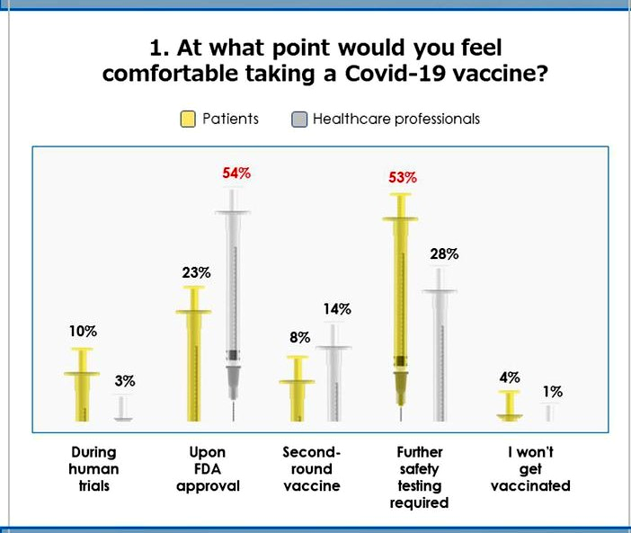

The United states FDA is a federal agency of the department of health and human services who is responsible for protecting the public health by ensuring security of human drugs.

In the graph shown above, it can be seen that less percentage of patients are comfortable taking a Covid 19 vaccine than the healthcare professionals upon FDA approval . why?
_________________________________________________________________________
_________________________________________________________________________

FRAMEWORK | CHARACTERISTICS
Competency | Evaluate and design scientific enquiry
Knowledge-system | Living system
Context | global
Cognitive demand | Medium
Item format | open constructed response type
Proficiency level | 3

√ | Text
 | Image
 | Table
√ | Graph
 | Map
 | Poem

Question 4
What does the picture given below depict about novel corona virus?

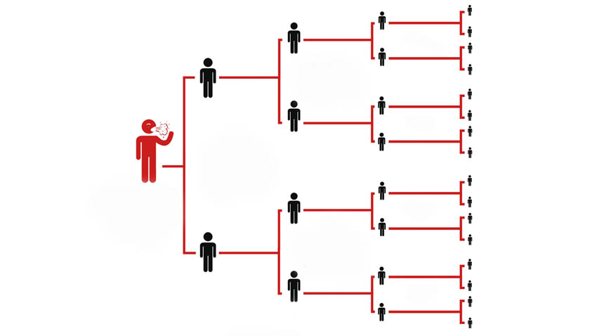

__________________________________________________________________________

FRAMEWORK | CHARACTERISTICS
Competency | Explain phenomenon scientifically
Knowledge-system | Living system
Context | Global
Cognitive demand | Easy
Item format | Short constructed response type
Proficiency level | 2

 | Text
√ | Image
 | Table
 | Graph
 | Map
 | Poem

CREDIT PATTERN ITEM - 5
Question 1
Full Credit: c) disease that are caused by virus, Ebola, Covid, rabies
No credit: wrong or missing

Question 2
Full Credit: both statements can be correct as the per the student’s views
No credit: missing

Question 3
Full Credit: because as compared to patients, healthcare professionals are much aware of the authentic reports of FDA and they know that FDA approval guarantee safety of humans for drugs
Partial credit: partial correct answer
No credit: wrong or missing

Question 4
Full Credit: the picture depicts the spread of infection of Covid 19 and how many people one person with the corona virus can infect.
Partial credit: Partially correct answer
No credit: wrong or missing

Name of the Teacher/Item Writer :Ms. TRIPTI SHARMA (Test Items 1 to 5)
Designation : TGT (SCIENCE)
Email : triptysharma@gmail.com
Phone No .7042527854
Name of the Vidyalaya : Kendriya Vidyalaya Janakpuri shift 1
KVS Region : Delhi

Test Item – 6 Reading blood report
A complete blood count (CBC) is a test that measures the cells that make up your blood: red blood cells, white blood cells and platelets. This test measures the WBCs which if low, risks you for infection. Number of RBCs is counted for anaemia. Hgb (haemoglobin) is the protein in your blood that holds the oxygen. MCV (mean corpuscular volume) is the average size of your red blood cells. Deficiency of vitamin B12 leads to higher level of MCV. Platelets play an important role in clotting.
Read the following report carefully:
Blood component | Mean | deviation | patient result
White blood cells count | 7.25 | 1.95 | 5.3
Haemoglobin | 14.75 | 1.75 | 13
MVC | 78-99 | N/A | 84fL
Platelets | (150-400)x10⁹ | N/A | 180 x 10⁹

Question1.
Considering the reference range of platelet count of a healthy human being, which of the patient is at the fatal risk of dengue?
Patient | platelet count
A | > 1.2x10⁴
B | =1.8x 10⁹
C | < 2x10³

competency | Interpreting data and evidence scientifically
Knowledge system | content
context | global
Cognitive demand | medium
Item format | Multiple choice question
Proficiency level | III
Description of item | Table

Question2
WBCs are the cells which fight against the infection but when a human body is infected by HIV it weakens the immune system. Following is the WBCs count of three patients:
Patient A 2200/ micro liter
Patient B 15000/micro liter
Patient C 9000/micro liter
*Reference range 4000-11000 / micro liter

Match the inferences which can be drawn from above results:
Patient | Inference
A | Normal health
B | infections including tuberculosis or HIV
C | Cancer/physical or mental stress/inflammation/allergy

Competency | Interpreting data and evidence scientifically
Knowledge system | procedural
Context | global
Cognitive demand | medium
Item format | Close constructed question
Proficiency level | III
Description of item | Table

Question3
It is recommended by doctors to not brush teeth when one is diagnosed with dengue.
Circle the correct answer AGREE/DISAGREE
Support your option with a suitable argument.
______________________________________________________________________________________________________________________________________________________
competency | Interpreting data and evidence scientifically
Knowledge system | Content
context | Global
Cognitive demand | Medium
Item format | Complex choice question
Proficiency level | IV
Description of item | Text

Question4.
A patient requires a medical diagnosis to identify the disease. Some of his symptoms are gum bleeding, high fever, headache, muscle and joint pain, vomiting, easy bruising, nosebleeds. The doctor identifies in his early diagnosis that it is dengue fever. What signs does the doctor see? Give any two.
___________________________________________________________________________________________________________________________________________________________________________________________________________________________________________________________________________________________________________________________________________________________

competency | Interpreting data and evidence scientifically
Knowledge system | Procedural
context | Global
Cognitive demand | Low
Item format | Close constructed response
Proficiency level | II
Description of item | Text

Answer key and credits:
Test Item 6 - Reading blood report
1. Full credit- C
No credit-missing or any other response
2. Full response- A-ii, B-iii, C-i
Partial credit- if any two responses are correct
No credit- missing or If two or more than two responses are incorrect
3. Full credit- Agree and suitable reason is given
Partial credit- only circled agree
No credit- Missing or incorrect answer
4. Full credit- gum bleeding, easy bruising, nosebleed (any two given)
Partial credit- one correct is given and another is either missing or incorrect
No credit-missing or incorrect answer

Test Item – 7 Health is wealth
Your health is the center of your life. Every part of your life relies on you having a good health. Your energy level reflects your overall health and wellbeing. What most people don’t realize is that there is a symbiotic relationship between your health and different parts of your life. Our health is made up of four layers viz. physical , mental , emotional and spiritual.

Question 1.

It’s true that there should be a symbiotic relationship among various aspects of life namely physical, mental, emotional and spiritual but which aspect is most likely to be affected by the harm caused by pathogens?
a. physical aspect
b. mental aspect
c. emotional aspect
d. spiritual aspect

competency | Explaining phenomena scientifically
Knowledge system | Content
Context | Global
Cognitive demand | Low
Item format | Multiple choice question
Proficiency level | II
Description of item | Text

Question 2.
Which one of these will face difficulty in facing daily minor annoyance in long term?
a. Hungry person for a month
b. Malnourished person
c. Both will face equally

competency | Explaining phenomena scientifically
Knowledge system | Content
Context | Global
Cognitive demand | Low
Item format | Multiple choice question
Proficiency level | I
Description of item | Text

Question3.
Advice: Sleep can have a serious impact on your overall health and wellbeing. One good habit to have a sound sleep is to avoid caffeine after 2pm.
What will you cut from your diet to nullify the effect of caffeine on your health? Name any two.
______________________
______________________
Competency | Explaining phenomena scientifically
Knowledge system | Content
Context | global
Cognitive demand | Medium
Item format | Close constructed response
Proficiency level | III
Description of item | Text

Question 4.
Fill in the blank.
____________ is a disorder or bad functioning (malfunctioning) of mind or body which leads to the departure of good health.
a. Physical disease
b. Health
c. Disease
d. Infectious disease

competency | Explaining phenomena scientifically
Knowledge system | Content
Context | Global
Cognitive demand | Low
Item format | Multiple choice question
Proficiency level | II
Description of item | Text
Answer key and credits:
Test Item 7 - Health is wealth
1. Full credit- a
No credit- missing or incorrect answer
2. Full credit- b
No credit- missing or incorrect answer
3. Full credit- any two correct sources
Partial credit- one correct is given and another is either missing or incorrect
No credit-missing or incorrect answer
4. Full credit- c
No credit-missing or incorrect answer

Test Item – 8 Typhoid

Typhoid is an illness caused by a bacterium called Salmonella typhi and is contracted by drinking water or eating food contaminated by Salmonella. The symptoms include continuous fever, headache, nausea, constipation or diarrhea, hoarse cough.
Three simple rules for preventing typhoid
- Cook your food.
- Boil or add bleach to your drinking water.
- Wash your hands.
A study was conducted in 5 countries namely China, India, Indonesia, Pakistan and Vietnam to assist WHO in making decisions on which geographical areas have to be targeted and to vaccinate in Asia against Typhoid fever.
One of the finding is given below in the image:

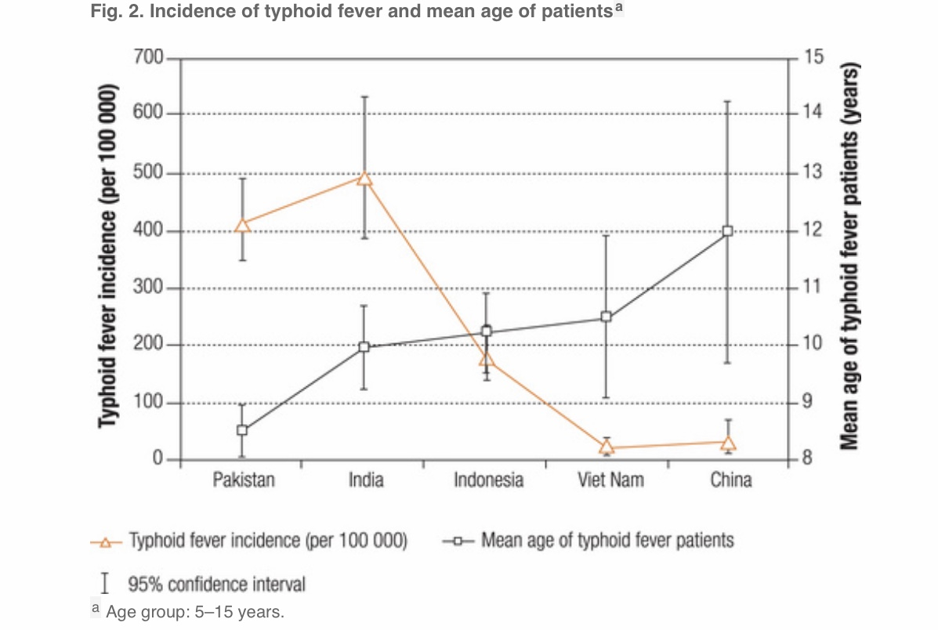

Question 1.
What is the mean age of typhoid patients in India?
___________________________________________________________________________________________________________________________________________________________________________
competency | Interpreting data and evidence scientifically
Knowledge system | Procedural
Context | Global
Cognitive demand | Medium
Item format | Close constructed response
Proficiency level | IV
Description of item | Graph

Question 2.
Which country has lowest risk from Salmonella typhi?
________________________
competency | Interpreting data and evidence scientifically
Knowledge system | Procedural
Context | Global
Cognitive demand | Medium
Item format | Close constructed response
Proficiency level | IV
Description of item | Graph

Question3.
Which of the following sequence of countries should WHO follow to start vaccination Programme considering the impact of Typhoid?
a. Indonesia, China, India, Pakistan, Vietnam
b. India, Pakistan, Indonesia, China, Vietnam
c. Pakistan, Vietnam, China, India, Indonesia
d. Vietnam, China, Indonesia, Pakistan, India

Competency | Interpreting data and evidence scientifically
Knowledge system | Procedural
Context | Global
Cognitive demand | Medium
Item format | Multiple choice question
Proficiency level | IV
Description of item | Text

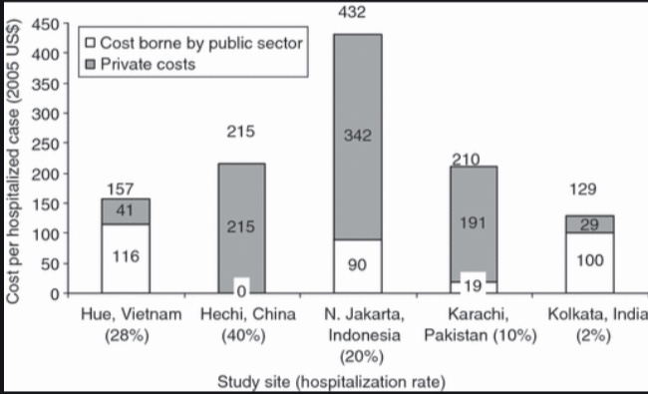

Above is a picture depicting the cost borne by the 5 Asian countries to treat typhoid in hospitals.
Question 4.
Which country’s government bears least cost of hospitalized cases?
___________________
Competency | Interpreting data and evidence scientifically
Knowledge system | Procedural
Context | Global
Cognitive demand | Medium
Item format | Close constructed response
Proficiency level | IV
Description of item | Graph

Question 5.
According to you which country’s government is most concern about its citizen’s health?
___________________
Support your answer with facts.
______________________________________________________________

Competency | Interpreting data and evidence scientifically
Knowledge system | Procedural
Context | Global
Cognitive demand | High
Item format | Close constructed response
Proficiency level | V
Description of item | Graph and text

Answer key and credits:

Test Item 8 - Typhoid
1. Full credit- 10
No credit-missing or incorrect answer
2. Full credit- Vietnam
No credit-missing or incorrect answer
3. Full credit- b
No credit-missing or incorrect answer
4. Full credit- China
No credit-missing or incorrect answer
5. Full credit- Vietnam, because it bears the highest expenditure in all the 5 countries.
Partial credit- only Vietnam is written
No credit-missing or incorrect answer

Test Item – 9 Obesity and overweight

Overweight and obesity are defined as abnormal or excessive fat accumulation that may impair health. Body Mass Index (BMI) is a simple index of weight-for-height that is commonly used to classify overweight and obesity in adults. It is defined as a person’s weight in kilograms divided by the square of his height in meters. It is given in kg/m².
Question 1.
For adults, WHO has set the following criteria:
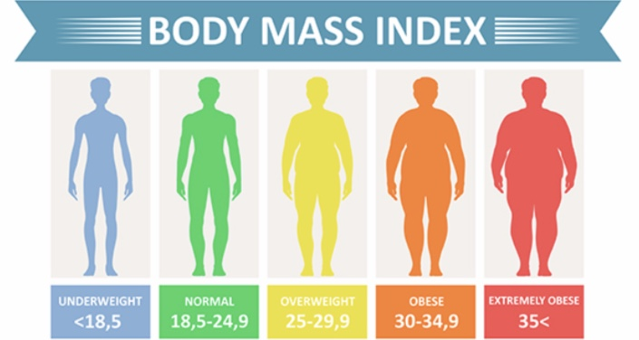
Who among the following is at the greatest health risk?
Person Name | Weight (kg) | Height(m)
Karan | 75 | 1.75
Neeraj | 83 | 1.83
Nitin | 80 | 1.55
Manish | 85 | 1.75
competency | Interpreting data and evidence scientifically
Knowledge system | Procedural
Context | Global
Cognitive demand | High
Item format | Multiple choice question
Proficiency level | V
Description of item | Image and table

Question 2.
The fundamental cause of obesity and overweight is an energy imbalance between calories consumed and calories expended. What could be the main reason of this imbalance?
a. increased intake of carbohydrates rich food
b. increased intake of protein rich food
c. increased intake of fat rich food.

competency | Explaining phenomena scientifically
Knowledge system | Content
Context | Global
Cognitive demand | Low
Item format | Multiple choice question
Proficiency level | II
Description of item | Text

Question 3.
Fact: At individual level, people can reduce the problem of overweight and obesity.
How it could be done? Suggest any two ways.
a.____________________________________________________________________
b.____________________________________________________________________
Competency | Explaining phenomena scientifically
Knowledge system | Procedural
Context | Global
Cognitive demand | Medium
Item format | Open constructed response
Proficiency level | III
Description of item | Text

Question 4.
Obesity can lead to various other serious health concerns. Reproductive health related concerns are one of them. Use the following image and find out what are those reproductive health concerns?

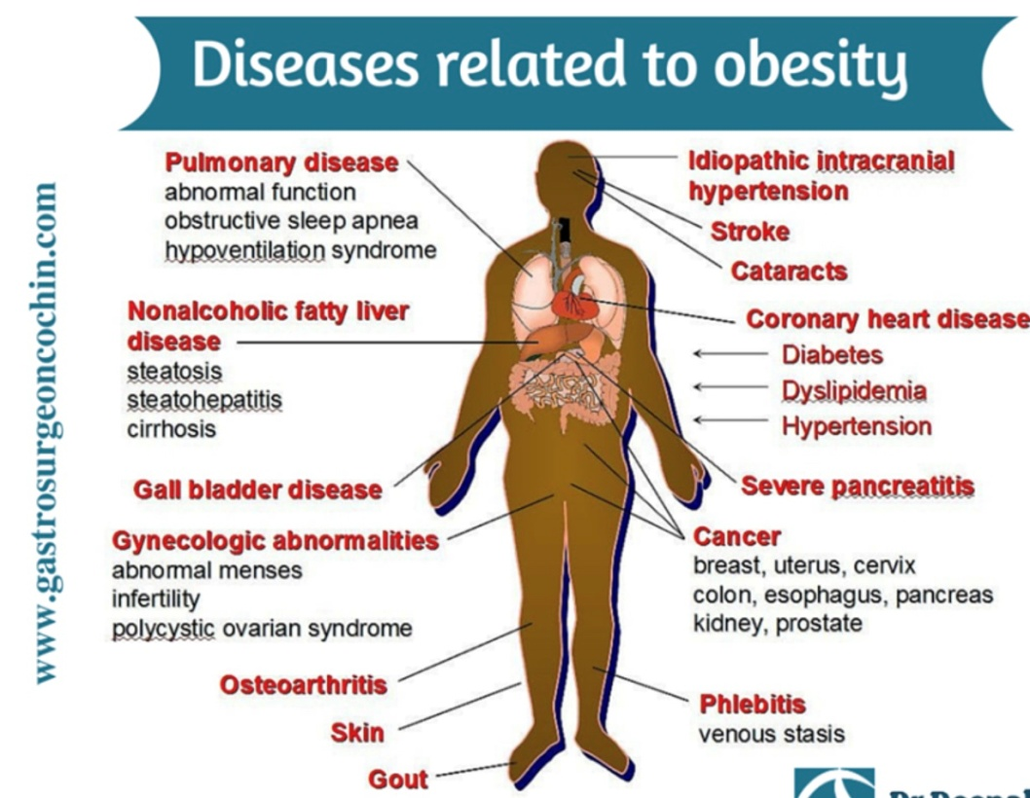
_________________________________________________________________
competency | Interpreting data and evidence scientifically
Knowledge system | Content
Context | Global
Cognitive demand | Medium
Item format | Close constructed response
Proficiency level | IV
Description of item | Image
Question 5.
Using the figure given in question no. 4, identify the two bones related diseases arising due to obesity.
______________________________________________
competency | Interpreting data and evidence scientifically
Knowledge system | Content
Context | Global
Cognitive demand | Medium
Item format | Close constructed response
Proficiency level | IV
Description of item | Image

Answer key and credits:

Test Item 9 - Obesity and overweight
1. Full credit- Nitin
No credit-missing or incorrect answer
2. Full credit – c
No credit-missing or incorrect answer
3. Full credit- any two valid responses
Partial credit- one correct is given and another is either missing or incorrect
No credit-missing or incorrect answer
4. Full credit- abnormal menses, infertility, polycystic ovarian syndrome
Partial credit- any two correct are given
No credit-missing or incorrect answer
5. Full credit- osteoarthritis, gout
Partial credit- any one is given
No credit-missing or incorrect answer

Test Item – 10 CAM Approaches in treatment
More than 80 percent of people in developing countries cannot afford the most basic medical procedures, drugs, and vaccines. Among wealthier populations in both developed and developing countries, complementary and alternative practices are popular among population.
India is known for its GREAT traditional medicinal systems—Ayurveda, Siddha, and Unani. The Indian subcontinent is a vast repository of medicinal plants that are used in traditional medical treatments. The alternative medicines in the traditional systems are derived from herbs, minerals, and organic matter, while for the preparation of herbal drugs only medicinal plants are used. The proportion of use of plants in the different Indian systems of medicine is Ayurveda 2000, Siddha 1300, Unani 1000, Homeopathy 800, Tibetan 500, Modern 200, and folk 4500.
Increased side effects, lack of curative treatment for several chronic diseases, high cost of new drugs, microbial resistance and emerging, diseases are some reasons for renewed public interest in Complementary and Alternative Medicines.

Question 1.
“Several studies have found that CAM approaches cost the same or more than conventional treatments.”
Considering above statement to be true, what could be the motivating reasons for people to approach CAM practices?

Competency | Explaining phenomena scientifically
Knowledge system | Procedural
Context | Global
Cognitive demand | Medium
Item format | Close constructed response
Proficiency level | IV
Description of item | Text

Question 2.
Plants have found great role in CAM approaches. Indian traditional medicinal system is one of those. The four systems where plants have most of the proportion in terms of usage are:
a. siddha, folk, Ayurveda, Unani
b. siddha, homeopathy, modern, Tibetan
modern, Ayurveda, Unani, Tibetan
Competency | Interpreting data and evidence scientifically
Knowledge system | Content
Context | Global
Cognitive demand | Medium
Item format | Multiple choice question
Proficiency level | III
Description of item | Text

Question 3.
The effectiveness of traditional methods of treatment can be proved scientifically.
Do you AGREE/ DISAGREE.
Develop an argument in support of your opinion.
competency | Interpreting data and evidence scientifically
Knowledge system | Procedural
Context | Global
Cognitive demand | Medium
Item format | Complex choice question
Proficiency level | IV
Description of item | Text

Answer key and credits:
Test Item 10 - CAM Approaches in treatment
No credit-missing or incorrect answer
2. Full credit-a
No credit- missing or incorrect answer

1. Full credit: any two of these (Increased side effects, lack of curative treatment for several chronic diseases, high cost of new drugs, microbial resistance and emerging)
Partial credit- any one of the above
3. Full credit- agree and supports with a valid reason
Partial credit- agree but reason is either missing or inappropriate
No credit-missing or incorrect answer

Name of the teacher- Reena Yadav (Test Items 6 to 10)
Designation- TGT Science
Email id- yadavreena009@gmail.com
KV No.3 Delhi Cantt (II Shift)
KVS RO Delhi

