CRITICAL AND CREATIVE THINKING TEST ITEMS

CLASS IX SUB: SCIENCE CHAPTER-11: WORK AND ENERGY
INDEX
S.No: | Topic
1 | Physical Exercise
2 | Conservation of Energy
3 | Reducing House hold Energy consumption
4 | Estimation of Electricity Bill
5 | Types of Energy
6 | Type of Work
7 | Mechanical Work done equivalent of Heat
8 | Conservation of electrical energy for future generation
9 | Forms of Energy
10 | Launch of a Rocket

CREATIVE AND CRITICAL THINKING (CCT) - SCIENTIFIC LITERACY

PRACTICE ASSESSMENT
Text- 1 PHYSICAL EXERCISE

Domain – Scientific literacy | Theme- WORK | Class –IX  Expected Time-20 minutes Total credit-10 marks
Description of item  √ Text  √ Image  Table  Graph  Map  Poem | Learning outcome-Students will be able to understand about the concept work done.

Regular but moderate physical exercise is good for our health.
Refer the text and Response the questions below

Question 1.1:Why do you have to breathe more heavily when you’re doing physical exercise than when your body is resting? ................................................................................................................................... ................................................................................................................................... ...................................................................................................................................

Framework | CHARACTERISTICS
Competency | Explain phenomena scientifically
Knowledge system | Content Knowledge
Context | Global
Cognitive Demand | Medium
Item format | Open constructive
Proficiency level | Level 1

Question 1.2:What happens when muscles are exercised?
................................................................................................................................... ................................................................................................................................... ...................................................................................................................................

Framework | CHARACTERISTICS
Competency | Explain phenomena scientifically
Knowledge system | Content Knowledge
Context | Global
Cognitive Demand | Medium
Item format | (Open Constructed)
Proficiency level | Level 1

Question 1.3: Is a person running kinetic energy?
................................................................................................................................... ................................................................................................................................... ...................................................................................................................................

Framework | CHARACTERISTICS
Competency | Explain phenomena scientifically
Knowledge system | Content Knowledge
Context | Global
Cognitive Demand | Hots
Item format | Closed Constructed
Proficiency level | Level 2

Question 1.4: Why runners feel hot when they are running?
…………………………………………………………………………………..

Framework | CHARACTERISTICS
Competency | Explain phenomena scientifically
Knowledge system | Content Knowledge
Context | Global
Cognitive Demand | Medium
Item format | Open constructive
Proficiency level | Level 1

Question 1.5: What are the advantages of regular physical exercise? Circle “Yes” or “No” for each statement.
Is this an advantage of regular physical exercise? | Yes or No?
Physical exercise helps prevent heart and circulation illnesses. | Yes / No
Physical exercise leads to a healthy diet. | Yes / No
Physical exercise helps to avoid becoming overweight. | Yes / No

Framework | CHARACTERISTICS
Competency | Explain phenomena scientifically
Knowledge system | About EXERCISES
Context | Global
Cognitive Demand | Medium
Item format | Complex MCQ
Proficiency level | Level 2

SCORING 1.1
Full Credit.
i)To remove increased levels of carbon dioxide and to supply more oxygen to your body.
• Breathing faster allows more oxygen into the blood and more carbon dioxide to be removed.
No Credit:
Other responses. • To get more air in your lungs. • Because muscles consume more energy. • Because your heart beats faster.
SCORING 1.2.
Full Credit:Muscles get an increased flow of blood.
No Credit:Fats are formed in the muscles or missing.
Scoring1.3:
Full Credit: Kinetic Energy is generated by the human body when it is in motion
No Credit: No or missing
Scoring 1.4:
Full credit: For instance, a runner builds up kinetic energy that starts in the feet and legs and is generally converted to heat.
No Credit: Other Response or Missing
SCORING 1.5
Full Credit:ll three correct: Yes, No, Yes in that order.
No Credit:Other responses.

Text – 2 (CONSERVATION OF ENERGY)

Domain – Scientific literacy | Theme-ENERGY | Class –IX  Expected Time-20 minutes Total credit-10 marks
Description of item  √ Text  √ Image  Table  Graph  Map  Poem | Learning outcome-Students will be able to understand about the CONSERVATION OF ENERGY

What is vital about the conservation of energy is human habits and practice.most peaple do not feel it to be necessary or important to save energy for the future.It does not occur to them that reckless spending of energy can be desastrous for their children when they growup.there are many ways in which conservation of energy can happen.

.

Refer the diagram and text Response the questions below-

Question 2.1: How can the conservation of energy be done in a systematic manner?
Framework | CHARACTERISTICS
Competency | Explain phenomena Through daily life example
Knowledge system | Text about conservation of energy
Context | Global
Cognitive Demand | Medium
Item format | Open constructed (Open constructed)
Proficiency level | Level 1

Question 2.2: How is the conservation of energy-related to pollution?
Framework | CHARACTERISTICS
Competency | Explain phenomena Through daily life example
Knowledge system | Text about conservation of energy
Context | Global
Cognitive Demand | Medium
Item format | Open constructive (Open constructed)
Proficiency level | Level 2

Question 2.3:what are the reasons for energy conservation?
i) Fossil fuels are non-renewable
ii)The demand of energy is increasing due to industrialization,
iii) Both
Framework | CHARACTERISTICS
Competency | Explain phenomena Through daily life example
Knowledge system | Content Knowledge
Context | Global
Cognitive Demand | Medium
Item format | MCQ (Open constructed)
Proficiency level | Level 1

Question 2.4 If you are using a generator, then please answer the question.
What are the environmental threats of generators?
………………………………………………………………………………..
Framework | CHARACTERISTICS
Competency | Explain phenomena Through daily life example
Knowledge system | Text about conservation of energy
Context | Global
Cognitive Demand | Medium
Item format | Closed constructed (Open constructed)
Proficiency level | Level 1

Question 2.5: What are the environmental benefits of using solar energy?
- Does not generate smoke 2) Does not create noise 3) Both

Framework | CHARACTERISTICS
Competency | Explain phenomena Through daily life example
Knowledge system | Text about conservation of energy
Context | Global
Cognitive Demand | Medium
Item format | Simple MCQ (Open constructed)
Proficiency level | Level 1

Scoring 2.1:
Full Credit: Energy is conserved in various ways in which it can be saved utilized for future use.
No Credit: No relevant response

Scoring 2.2:
Full Credit-Less of energy consumption leads to lowering of toxins in air. This is how energy conservation control pollution.
No Credit: No relevant response

Scoring 2.3:
Full Credit: Option (iii)
No Credit: other option

Scoring 2.4:
Full Credit: The hazards associated with portable generators include electric shock, carbon monoxide gas, and fire. ... Overloading a generator can also cause fires
No Credit: No relevant response or missing

Scoring 2.5:
Full Credit: Both
No Credit: No response

Text Item -3 (Reducing household energy consumption)

Domain – Scientific literacy | Theme- Energy | Class –IX  Expected Time-20 minutes Total credit-10 marks
Description of item  √ Text  √ Image  Table  Graph  Map  Poem | Learning outcome-Students will be able to understand the applications of household appliances

Overall the results indicated that income and demographic features predicted historic energy consumption but not changes in consumption during the field study, where environmental attitudes and feedback were influential. Of all the feedback groups, the installation of computers helped reduce consumption most markedly. Furthermore, people with positive environmental attitudes, but who had not previously been engaged in many conservation actions, were more likely to change their consumption subsequent to the feedback period for example-If in US 1000000 households replaced 3 incandescent light bulbs with LED light bulbs, then carbon dioxide emissions change by 0.6%. Recommendations are made both for energy conservation policy and future research.

Refer the text and Response the questions below–
Question3.1: If 3000000 American household replaced 3 incandescent light bulbs with LED light bulbs, how would US carbon dioxide emissions change?
i)0.75% increase ii)0.1% decrease iii)1.8% decrease iv)6% decrease
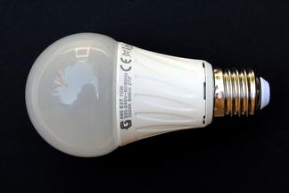

Framework | CHARACTERISTICS
Competency | Explain phenomena scientifically
Knowledge system | Text about energy
Context | household science
Cognitive Demand | Medium
Item format | Closed Constructed
Proficiency level | Level 2

Question 3.2: What uses more energy? Six hours of laptop use or making coffee?
- Laptop uses more energy
- Coffee uses more energy
They are about the same

Framework | CHARACTERISTICS
Competency | Explain phenomena scientifically
Knowledge system | Text about energy
Context | household science
Cognitive Demand | Medium
Item format | MCQ
Proficiency level | Level 1

Question3.3:Will the energy consumption of A.C. decreases if the room temperature is much lower than the outside temperature?

Framework | CHARACTERISTICS
Competency | Explain phenomena scientifically
Knowledge system | Text about energy
Context | household science
Cognitive Demand | Medium
Item format | Close constructive
Proficiency level | Level 1

Question3.4: What is the best solution for heat loss through windows in existing buildings?

Framework | CHARACTERISTICS
Competency | Explain phenomena scientifically
Knowledge system | Text about energy
Context | household science
Cognitive Demand | Medium
Item format | Open constructive
Proficiency level | Level 2

Question3.5: Which one of the following does not conserve energy?

a) Turning off electrical appliances when not in use.
b) Build more power plants to supply more electrical energy
c) Use energy efficient machines
d)Recycling

Framework | CHARACTERISTICS
Competency | Explain phenomena scientifically
Knowledge system | Text about energy
Context | Household science
Cognitive Demand | Medium
Item format | Open constructive
Proficiency level | Level 2

Scoring3.1:
Full Credit:1.8% decrease in total US carbon dioxide emissions.
This example illustrates the usefulness of doing some basic calculations to quantify the benefit of this energy-saving measure.
Partial Credit: Some relevant response
No Credit: Other option or Missing

Scoring3.2.
Full Credit: They are about the same.
A laptop uses 15-60 watts of electricity. The exact amount depends on the type of laptop and the intensity of the use such as how many programs are open, if a CD is spinning, or if the hard drive is in frequent use. Six hours of laptop use at 45 watts equals 270 watt-hours.
Making coffee can be accomplished by several methods. A typical coffee maker uses 900 watts of electricity and runs for approximately 15 minutes, yielding 225 watt-hours of energy demand. To make coffee on the stovetop, an electric burner uses 2500 watts and takes about 5 minutes to boil a kettle of water. This works out to be 208 watt-hours.
Partial Credit: relevant response
No Credit: No response

Scoring 3.3:
Full Credit: Yes, there is a huge impact in the consumption of energy by A.C. The load of work done by A.C. decrease if the room temperature decreases. And most probably the room temperature will always be lower than the outside temperature. Also note that: A degree (in °C) rise in A.C temperature will decrease its energy consumption by almost 6%.
No Credit: Other response
Scoring 3.4:
Full Credit: If you want to reduce your energy bill, it is quite possible to insulate the roof and walls. However, windows are a more difficult subject, and they let out significant amounts of heat. We can use the glasses of concave shape in windows.
No Credit: No response
Scoring3.5:
Full credit: Option (b)
No Credit: Any other option
Name of the Teacher: SHIV KISHORDesignation: PGT Physics
Email: shivkishore57@gmail.com
Phone No.: 9450321235Name of the Vidyalaya: Kendriya Vidyalaya AFS Manauri, Prayagraj
KVS Region: Varanasi

CREATIVE AND CRITICAL THINKING (CCT) -- PRACTICE ASSESSMENT

SCIENTIFIC LITERACY
PRACTICE ITEM NO.1
Estimation of Electricity Bill

The watt (W) is a unit of electrical power, which is the rate at which we use energy. We pay the electric company for the use of energy. A kilowatt (kW) is equal to 1000 watts: kilo is a prefix that means 1000. (Note that k is the normal prefix for kilo, W is the normal abbreviation for Watts and h is the normal abbreviation for hours). A watt-hour (Wh) and a kilowatt-hour (kWh) are units of energy, where 1000 Wh= 1 kWh.

Domain: Scientific Literacy | Theme: Work& Energy | Class(es): IX  Expected Time: 20 Min.  Total Credit: 10
Description of Item:  √ Text  √ Image  Table  Graph  Map  Poem | Learning Outcomes (As per NCERT):  (i) Understand the content of image  (ii) able to relate with scientific phenomenon  (iii) Estimation of Electricity Bill

Q.1. If a house having 10 bulbs of 10W each and it turned ON for 10 hours daily. What will be the reading of electric meter in a month? If rate of cost is Rs. 5 per unit, estimate the electricity bill?

FRAMEWORK | CHARACTERISTICS
Competency | Analysis of diagram & text scientifically
Knowledge system | Content knowledge
Context | Global
Cognitive demand | Problem Solving
Item Format | Short response
Proficiency Level | 2
Description of Answer Key and Credits:
CREDIT PATTERN:
Full Credit : Meter reading 30 units and
cost of electricity bill 30 units × Rs5 = Rs150(2 Marks)
Partial Credit : Any one response(1 Mark)
No Credit : For other options (Nil)

Q.2.Can you suggest if two electric appliances AC and geyser having wattage 1000W and 750W respectively are turned ON for same duration, which electric appliances consume more electricity?
FRAMEWORK | CHARACTERISTICS
Competency | Analysis of phenomenon scientifically
Knowledge system | Content knowledge
Context | Global
Cognitive demand | Problem solving
Item Format | Short Response
Proficiency level | 2

Description of Answer Key and Credits:
CREDIT PATTERN:
Full Credit : ACof 1000 W(2marks)
Partial Credit : NA (NA)
No Credit : For other options (Nil)

Q.3. The commercial unit of consumption of electricity is equivalent to
(a) 1kWh
(b) 1 joule
(c) 1 joule/sec
(d) 1Wh

FRAMEWORK | CHARACTERISTICS
Competency | Scientific awareness
Knowledge system | Content knowledge
Context | Global
Cognitive demand | Evaluate and reflect
Item Format | Simple MCQ
Proficiency Level | 1(a)

Description of Answer Key and Credits:
CREDIT PATTERN:
Full Credit : (a.) (2marks)
Partial Credit:NA(NA)
No Credit : No or Any other irrelevant answer (Nil)

Q.4. Electricity bill can be minimised by taking simple steps. Can you suggest some of them?
FRAMEWORK | CHARACTERISTICS
Competency | Explain phenomenon scientifically
Knowledge system | Content knowledge
Context | Argument
Cognitive demand | Evaluate and reflect
Item Format | Close constructed response
Proficiency Level | 2

Description of Answer Key and Credits:
CREDIT PATTERN:
Full Credit: Use of LED bulbs in place of CFL and filament type bulbs
Use of low wattage electric appliances etc. (2marks)
Partial Credit: Only one option(1mark)
No Credit: For any other answer(Nil)

Q.5. Various electric safety measures or devices must be installed in your house. Identify & list at-least 3 or 4 devices of your own house.
FRAMEWORK | CHARACTERISTICS
Competency | Explain phenomenon scientifically
Knowledge system | Content knowledge
Context | Global
Cognitive demand | Interpreting
Item Format | Open Constructed Response
Proficiency Level | 2

Description of Answer Key and Credits:
CREDIT PATTERN:
Full Credit: Electric fuse, MCB, earth wire etc.(2marks)
Partial Credit: If only one or two examples are given.(1 Mark)
No Credit : NA(Nil)

PRACTICE ITEM No.2

TYPES of energy

All forms of energy are associated with motion. For example, any given body has kinetic energy if it is in motion. If any body contains potential energy because of its configuration. Similarly, nuclear energy is potential energy because it results from the configuration of subatomic particles in the nucleus of an atom. Energy can be neither created nor destroyed but only changed from one form to another. This principle is known as the conservation of energy. For example, when a box slides down a hill, the potential energy that the box has from being located high up on the slope is converted to kinetic energy.

Domain: Scientific Literacy | Theme: Work & Energy | Class(es): IX  Expected Time: 20 Min.  Total Credit: 10
Description of Item:  √ Text  Image  Table  Graph  Map  Poem | Learning Outcomes (As per NCERT):  (i) Understand content of the image  (ii) able to relate with scientific phenomenon  (iii) able to understand different kinds of energy

Q.1. A stretched string of a bow is an example of
(a) Kinetic Energy
(b) Potential Energy
(c) Nuclear Energy
(d) Thermal Energy

FRAMEWORK | CHARACTERISTICS
Competency | Analysis of phenomenon scientifically
Knowledge system | Content knowledge
Context | Global
Cognitive demand | Interpreting
Item Format | Simple MCQ
Proficiency Level | 1(b)

Description of Answer Key and Credits:
CREDIT PATTERN:
Full Credit : (b.) Potentialenergy (2marks)
Partial Credit : NA (NA)
No Credit : For other options (Nil)

Q.2.If a ball of 50g is dropped from a height of 10m from the ground. Calculate the kinetic energy of ball when it hit on the ground? (g = 10 m/s²)

FRAMEWORK | CHARACTERISTICS
Competency | Analysis of phenomenon scientifically
Knowledge system | Content knowledge
Context | Argument
Cognitive demand | Problem Solving
Item Format | Close Constructed Response
Proficiency level | 2

Description of Answer Key and Credits:
CREDIT PATTERN:
Full Credit : Potential energy = Kinetic energy
mgh = KE
0.05×10×10 = 5 J(2marks)
Partial Credit : NA (NA)
No Credit : For other options (Nil)

Q.3. Energy can be transformed from one form to another form.Give some examples in which mechanical energy changes into heat energy?

FRAMEWORK | CHARACTERISTICS
Competency | Explain any diagram scientifically
Knowledge system | Content knowledge
Context | Argument
Cognitive demand | Evaluate and reflect
Item Format | Open Constructed Response
Proficiency Level | 3

Description of Answer Key and Credits:
CREDIT PATTERN:
Full Credit :Rubbing of palm, friction between road and tyre any other relevant answer.(2marks)
Partial Credit: Only one example(1 mark)
No Credit : No or Any other irrelevant answer (Nil)

Q.4. If energy is neither created nor destroyed then from where do we get energy? Justify your answer.

FRAMEWORK | CHARACTERISTICS
Competency | Explain phenomenon scientifically
Knowledge system | Content knowledge
Context | Argument
Cognitive demand | Evaluate and reflect
Item Format | Close constructed response
Proficiency Level | 2

Description of Answer Key and Credits:
CREDIT PATTERN:
Full Credit:Sun is ultimate source of energy.(2marks)
Justification – Energy is coming from sun to the earth through radiation & then it is changed from one form to another.
Partial Credit: Correct answer without justification (1mark)
No Credit: For any other answer (Nil)

Q.5. Suggest the kind of energy stored in mechanical watch (tensioned device).
(a.) Solar energy
(b.) Potential energy
(c.) Electric energy
(d.) None of the above

FRAMEWORK | CHARACTERISTICS
Competency | Explain phenomenon scientifically
Knowledge system | Content knowledge
Context | Global
Cognitive demand | Interpreting
Item Format | Simple MCQ
Proficiency Level | 1(b)
Description of Answer Key and Credits:
CREDIT PATTERN:
Full Credit : (b.) Potential energy(2marks)
Partial Credit : NA (Nil)
No Credit : NA(Nil)

PRACTICE ITEM No. 3

TYPE OF WORK
Work is the process of energy transfer to the motion of an object via application of a force, often represented as the product of force and displacement. A force is said to do positive work if the force has a component in the direction of the displacement of the point of application.
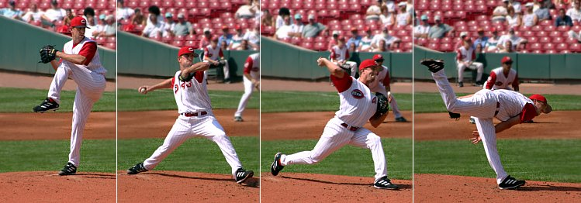
A baseball pitcher does positive work on the ball by applying a force to it over the distance it moves while in his grip.

Domain: Scientific Literacy | Theme: Type of work | Class(es): IX  Expected Time: 20 Min.  Total Credit: 10
Description of Item:  √ Text  √ Image  Table  Graph  Map  Poem | Learning Outcomes (As per NCERT):  (i) Understand the image  (ii) able to relate with scientific phenomenon

Q.1. A person is running on a circular track of radius 50m. Calculate the work done by the man after completing 5 rounds of this track? Justify your answer, also.
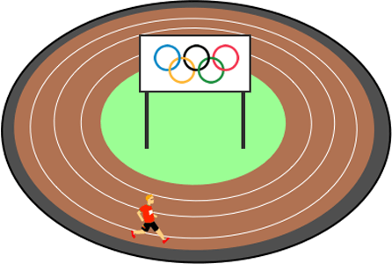

FRAMEWORK | CHARACTERISTICS
Competency | Analysis of diagram scientifically
Knowledge system | Content knowledge
Context | Global
Cognitive demand | Problem solving
Item Format | Close Constructed Response
Proficiency Level | 2

Description of Answer Key and Credits:
CREDIT PATTERN:
Full Credit : Zero as displacement is zero in this case.(2 Marks)
PartialCredit : if correct answer is given without justification.(1 Mark)
No Credit : For other options (Nil)

Q.2.A person carry 60kg of suitcase on his head and moves 5m ahead .What will be the work done by the gravity? (Value of g = 10 m/s² )
(a.) 3000 J
(b.) 300 J
(c.) 0 J
(d.) None of the above

FRAMEWORK | CHARACTERISTICS
Competency | Analysis of phenomenon scientifically
Knowledge system | Content knowledge
Context | Global
Cognitive demand | Problem Solving
Item Format | Simple MCQ
Proficiency level | 1(b)

Description of Answer Key and Credits:
CREDIT PATTERN:
Full Credit : (c.) 0 J(2marks)
Partial Credit : NA (NA)
No Credit : For other options (Nil)

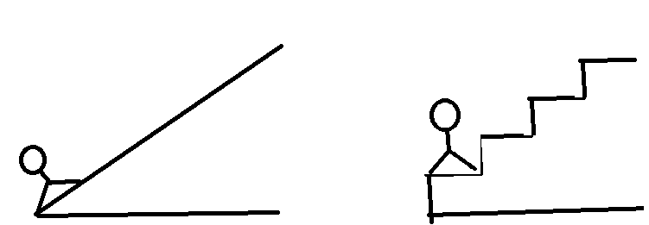
Q.3. As per the image given, a man walks on an inclined plane and a Staircase up to same height. Compare the work Done in both cases. Justify your answer, also.

FRAMEWORK | CHARACTERISTICS
Competency | Explain any diagram scientifically
Knowledge system | Content knowledge
Context | Argument
Cognitive demand | Evaluate and reflect
Item Format | Open Constructed Response
Proficiency Level | 2

Description of Answer Key and Credits:
CREDIT PATTERN:
Full Credit :In both cases work done is same as heights (displacements) from earth in both cases are equal.(2marks)
Partial Credit:In both cases work done is same(1 Mark)
No Credit : Any other irrelevant answer (Nil)

Q.4. In which of the following examples work has to be done
(i)A person is pushing the wall but no change takes place
(ii)A man completes single round on a circular path
(iii)A person is pulling a bucket from a well
(iv) None of the above

FRAMEWORK | CHARACTERISTICS
Competency | Explain phenomenon scientifically
Knowledge system | Content knowledge
Context | Argument
Cognitive demand | Evaluate and reflect
Item Format | Simple MCQ
Proficiency Level | 1(b)

Description of Answer Key and Credits:
CREDIT PATTERN:
Full Credit:(iii.)(2marks)
Partial Credit: NA(NA)
No Credit: For any other answer (Nil)

Q.5. Give at-least one example of all types of work - positive, negative and zero work.
FRAMEWORK | CHARACTERISTICS
Competency | Explain phenomenon scientifically
Knowledge system | Content knowledge
Context | Global
Cognitive demand | Interpreting
Item Format | Simple MCQ
Proficiency Level | 1(b)

Description of Answer Key and Credits:
CREDIT PATTERN:
Full Credit :Positive work - work done by a gravity force in a freely falling body.
Negative work - work done by an applied force when a person is moving on a straight road
Zero work - work done by a collie carrying luggage on his head. (2marks)
Partial Credit : If only two examples are given(1 Mark)
No Credit : If only one or no example is given (Nil)
Name of the Teacher/Item Writer: SUSHEEL KUMAR
Designation: PGT (Chemistry)
E-mail: susheelsky103@gmail.com
Phone No. : 7088129519
Name of the Vidyalaya: K V DLW Varanasi
KVS Region: Varanasi

CREATIVE AND CRITICAL THINKING (CCT) -SCIENTIFIC LITERACY
PRACTICE ITEM -1
Mechanical Work done equivalent of Heat

In 1845, the English physicist James Joule wrote a paper on the mechanical equivalent of heat for the British Association meeting in Cambridge. In this paper, he reported his best-known experiment, in which the mechanical power released through the action of a "weight falling through a height" was used to turn a paddle-wheel in an insulated barrel of water.
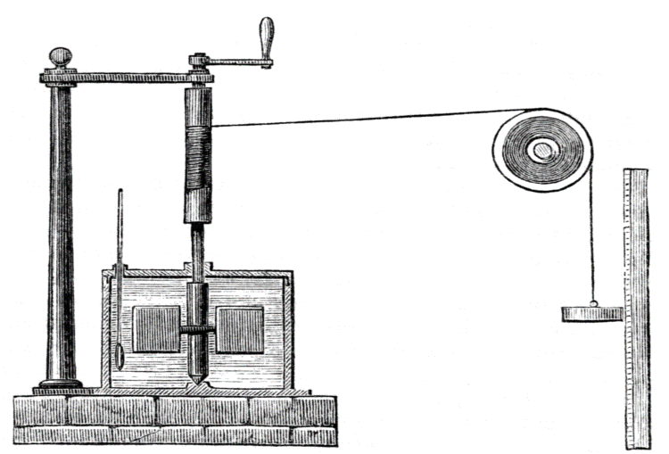

In this experiment, the motion of the paddle wheel, through agitation and friction, heated the body of water, so as to increase its temperature. Both the temperature change ∆T of the water and the height of the fall ∆h of the weight mg was recorded. Using these values, Joule was able to determine the mechanical equivalent of heat. Joule estimated a mechanical equivalent of heat to be 819 ft•lbf/Btu (4.41 J/cal). The modern-day definitions of heat, work, temperature, and energy all have connection to this experiment. In this arrangement of apparatus, it never happens that the process runs in reverse, with the water driving the paddles so as to raise the weight, not even slightly. Mechanical work was done by the apparatus of falling weight, pulley, and paddles, which lay in the surroundings of the water. Their motion scarcely affected the volume of the water. Work that does not change the volume of the water is said to be isochoric; it is irreversible. The energy supplied by the fall of the weight passed into the water as heat.
(Source- Wikipedia)

Domain: Scientific Literacy | Theme: Work and Energy | Class(es): IX/X  Expected Time: 15 Min.  Total Credit: 10
Description of Item:  √ Text  √ Image  Table  Graph  Map  Poem | Learning Outcomes (As per NCERT):  (i) Understand the conversion of mechanical energy into heat.  (ii) able to relate with scientific phenomenon

Q.1. What are the factors responsible for heat up the water in Joule's experiment?
FRAMEWORK | CHARACTERISTICS
Competency | Explain phenomenon scientifically with image
Knowledge system | Content knowledge
Context | Experimental study
Cognitive demand | Medium
Item Format | Open (Constructed)
Proficiency Level | 1(b)

Description of Answer Key and Credits:
CREDIT PATTERN:
Full Credit: (Mechanical work done) The motion of the paddle wheel, through agitation and friction . (2marks)
Partial Credit : any one Motion of peddle wheal or Friction (1 mark)
No Credit : For other response (Nil)

Q.2. if 20.0 calories of work are transferred as heat, how many Joules of heat is there? (Assume all work is transferred as heat)
(a) 8.82 Joules (b) 4.41 joules (c) 88.2 joules (d) 44.1 Joules

FRAMEWORK | CHARACTERISTICS
Competency | Explain phenomenon scientifically with image
Knowledge system | Content knowledge
Context | Experimental study
Cognitive demand | Evaluate and reflect
Item Format | Simple MCQ
Proficiency level | 1(a)

Description of Answer Key and Credits:
CREDIT PATTERN:
Full Credit : (c) (2marks)
Partial Credit : NA (NA)
No Credit : For other options (Nil)

Q.3. How the results of Joule's famous mechanical equivalent of heat experiment help us understand the law of conservation of energy.
- Joule discovered that heat is the same as energy and that is why we know that conduction is possible.
- Joule's experiment proves the law of conservation of energy because it is obvious that mechanical energy is equal to heat energy.
- Joule's mechanical equivalent of heat experiment helped us to understand that the mechanical work done on a system was equal to the heat produced. This supports the law of conservation of energy because it shows that energy is not created nor destroyed, only transformed.
- None of these.

FRAMEWORK | CHARACTERISTICS
Competency | Explain phenomenon scientifically with image
Knowledge system | Content knowledge
Context | Global
Cognitive demand | Medium
Item Format | Simple MCQ
Proficiency level | 2

Description of Answer Key and Credits:
CREDIT PATTERN:
Full Credit : (c) (2marks)
Partial Credit : NA (NA)
No Credit : For other options (Nil)

Q.4. If temperature of water rises in the experiment then what happens to the volume of water?
(a) Decreases (b) No change (c) Increases (d) first increases then decreases
FRAMEWORK | CHARACTERISTICS
Competency | Explain phenomenon scientifically with image
Knowledge system | Content knowledge
Context | Global
Cognitive demand | Medium
Item Format | Simple MCQ
Proficiency level | 2

Description of Answer Key and Credits:
CREDIT PATTERN:
Full Credit : (b) (2marks)
Partial Credit : NA (NA)
No Credit : For other options (Nil)

Q.5. What is the relation between temperature change ∆T of the water and the height of the fall ∆h of the body in the above experiment?
(a) Inversely proportional to each other
(b) Independent to each other
(c) Directly proportional to each other
(d) ∆T depends on square of ∆h.

FRAMEWORK | CHARACTERISTICS
Competency | Explain phenomenon scientifically with image
Knowledge system | Content knowledge
Context | Medium
Cognitive demand | Medium
Item Format | Simple MCQ
Proficiency level | 2

Description of Answer Key and Credits:
CREDIT PATTERN:
Full Credit : (c) (2marks)
Partial Credit : NA (NA)
No Credit : For other options (Nil)

Name of the Teacher: ShyamJiKesharwani
Designation: PGT Physics
Email: kesarwanishyam1984@gmail.com
Phone No.: 9559022942
Name of the Vidyalaya: KendriyaVidyalaya AmhatSultanpur
KVS Region: Varanasi

PRACTICE ITEM -2
Conservation of electrical energy for future generation
Energy needs to be conserved to protect our environment from drastic changes, to save the depleting resources for our future generations. We can save electrical energy in air conditioners and other electrical appliances by using different star ratings appliances as shown below.
(Source -https://qph.fs.quoracdn.net/main-qimgf3ead9f11d41800aa169a25f8a37e48e.webp)

Domain: Scientific Literacy | Theme: Work and Energy | Class(es): IX/X  Expected Time: 15 Min.  Total Credit: 10
Description of Item:  √ Text  Image  √ Table  Graph  Map  Poem | Learning Outcomes (As per NCERT):  (i) Understand the concept of electrical consumption  (ii) Understand the concept of conservation of energy

Q1. What is the annual cost of electricity bill for AC of 4-star rating and cooling capacity 1.50 TR.?
- Rs. 15794
- Rs. 11575
- Rs. 4219
- Rs. 15794

- FRAMEWORK | CHARACTERISTICS
Competency | Conservation of energy for future
Knowledge system | Content knowledge
Context | Global
Cognitive demand | Medium
Item Format | Simple MCQ
Proficiency level | 2

Description of Answer Key and Credits:
CREDIT PATTERN:
Full Credit : (b) (2marks)
Partial Credit : NA (NA)
No Credit : For other options (Nil)

Q2.Which type of AC is better for the least power consumption?
- FRAMEWORK | CHARACTERISTICS
Competency | Conservation of energy for future
Knowledge system | Content knowledge
Context | Global
Cognitive demand | medium
Item Format | Short response
Proficiency level | 2

Description of Answer Key and Credits:
CREDIT PATTERN:
Full Credit : 5 Star(2marks)
Partial Credit : (NA)
No Credit : For other response (Nil)

Q3. What is the difference between the annual cost of power consumption for 3-star rating AC and 4-star rating AC of 2.00 TR?
- Rs 1104 (b) Rs 4521 (c) Rs 5625 (d) Rs. 21058

- FRAMEWORK | CHARACTERISTICS
Competency | Conservation of energy for future
Knowledge system | Content knowledge
Context | Global
Cognitive demand | medium
Item Format | Simple MCQ
Proficiency level | 2

Description of Answer Key and Credits:
CREDIT PATTERN:
Full Credit : (a) (2marks)
Partial Credit : NA (NA)
No Credit : For other options (Nil)

Q4. What is the electrical charge in Rupees for 5 KW hr electrical consumption?

- FRAMEWORK | CHARACTERISTICS
Competency | Conservation of energy for future
Knowledge system | Content knowledge
Context | Global
Cognitive demand | Evaluate
Item Format | Short response
Proficiency level | 1(b)

Description of Answer Key and Credits:
CREDIT PATTERN:
Full Credit : Rs. 21.75 (2marks)
Partial Credit : (NA)
No Credit : For other response (Nil)

Q5. Is energy ever completely lost and gone forever?
FRAMEWORK | CHARACTERISTICS
Competency | Conservation of energy for future
Knowledge system | Content knowledge
Context | Global
Cognitive demand | Global
Item Format | Open constructed
Proficiency level | 2

Description of Answer Key and Credits:
CREDIT PATTERN:
Full Credit : According to conservation of energy “ energy can neither be created and nor be destroyed it can only transform from one form to another form” so energy can never be lost(2marks)
Partial Credit : No (01 mark)
No Credit : For other options (Nil)

Name of the Teacher: ShyamJiKesharwani
Designation: PGT Physics
Email: kesarwanishyam1984@gmail.com
Phone No.: 9559022942
Name of the Vidyalaya: KendriyaVidyalayaAmhatSultanpur
KVS Region: Varanasi

CREATIVE AND CRITICAL THINKING (CCT) - SCIENTIFIC LITERACY
PRACTICE ITEM No. 1

forms of energy

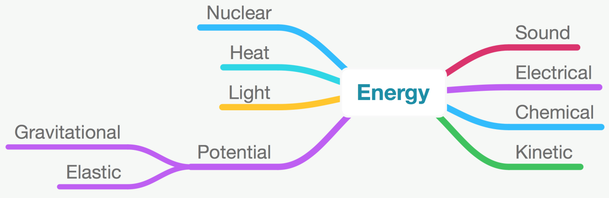

Domain: Scientific Literacy | Theme: Work& Energy | Class(es): IX  Expected Time: 15 Min.  Total Credit: 10
Description of Item:  √ Text  √ Image  Table  Graph  Map  Poem | Learning Outcomes (As per NCERT):  (i) Understand the image  (ii) able to relate with scientific phenomenon

Q.1. As per the image given above, which type of energy is stored in a stretched rubber band?
- Kinetic
- Chemical
- Elastic potential
- Sound

FRAMEWORK | CHARACTERISTICS
Competency | Analysis of diagram scientifically
Knowledge system | Content knowledge
Context | Global
Cognitive demand | Interpreting
Item Format | Simple MCQ
Proficiency Level | 1(b)

Description of Answer Key and Credits:
CREDIT PATTERN:
Full Credit : (c.) Elastic Potential (2marks)
Partial Credit : NA (NA)
No Credit : For other options (Nil)

Q.2.Which of the following statement is not correct -
- Gravitational Energy cannot be converted into any other forms of energy.
- One form of energy can be converted into any other form of energy.
- Energy can neither be created nor destroyed.
- Kinetic energy can be converted into potential energy but Potential energy cannot be converted into Kinetic energy.
Choose the correct options –
- i& iii
- i& iv
- only iv
- only i

FRAMEWORK | CHARACTERISTICS
Competency | Analysis of phenomenon scientifically
Knowledge system | Content knowledge
Context | Argument
Cognitive demand | medium
Item Format | Complex MCQ
Proficiency level | 2

Description of Answer Key and Credits:
CREDIT PATTERN:
Full Credit : (b) i& iv(2marks)
Partial Credit : NA (NA)
No Credit : For other options (Nil)

Q.3. As per the image given above gravitational & elastic forms of energies can be grouped as potential energy. Write your views with reasons.
FRAMEWORK | CHARACTERISTICS
Competency | Explain any diagram scientifically
Knowledge system | Content knowledge
Context | Global
Cognitive demand | Medium
Item Format | Open Constructed Response
Proficiency Level | 3

Description of Answer Key and Credits:
CREDIT PATTERN:
Full Credit :
Yes, Gravitational & elastic forms of energies can be grouped as potential energy as it can be stored in an object to perform any work by virtue of object’s position or its configuration.
Or
Any other relevant answer with proper justification(2marks)
Partial Credit: Any other relevant answer without justification(1 mark)
No Credit : No or Any other irrelevant answer (Nil)

Q.4. Life cannot be possible if transformation of energy does not take place in nature. Justify your views with reasons.

FRAMEWORK | CHARACTERISTICS
Competency | Explain phenomenon scientifically
Knowledge system | Content knowledge
Context | Global
Cognitive demand | Medium
Item Format | Close constructed response
Proficiency Level | 3

Description of Answer Key and Credits:
CREDIT PATTERN:
Full Credit: Yes, Life cannot be possible if transformation of energy does not take place in nature as energy is required by all forms of living organisms but in various different forms. For example –Plants require solar energy to perform photosynthesis whereas animals use energy stored by plants in chemical form.(2marks)

Partial Credit: Correct answer without justification(1mark)
No Credit: For any other answer(Nil)

Q.5. Choose correct option which shows conversion of Light energy into Electric energy –
(a.) Solar Cooker
(b.) Solar Panel
(c.) Sundial
(d.) None of the above
FRAMEWORK | CHARACTERISTICS
Competency | Explain phenomenon scientifically
Knowledge system | Content knowledge
Context | Global
Cognitive demand | Interpreting
Item Format | Simple MCQ
Proficiency Level | 2

Description of Answer Key and Credits:
CREDIT PATTERN:
Full Credit : (b.) Solar Panel (2marks)
Partial Credit : NA(Nil)
No Credit : NA(Nil)

Name of the Teacher/Item Writer: SAMEER SHUKLA
Designation: PGT (BIOLOGY)
E-mail: shuklasameer.kvm@gmail.com
Phone No. : 9455130518
Name of the Vidyalaya: K V Chitrakoot
KVS Region: Varanasi

CREATIVE AND CRITICAL THINKING (CCT) - SCIENTIFIC LITERACY
PRACTICE ITEM No. 2
Launch of a rocket

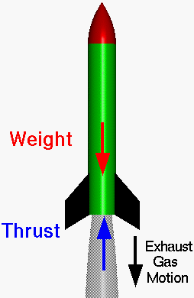

A rocket can lift off from a launch pad only when it expels gas out of its engine. The rocket pushes on the gas, and the gas in turn pushes on the rocket. With rockets, the action is the expelling of gas out of the engine. The reaction is the movement of the rocket in the opposite direction.
To enable a rocket to lift off from the launch pad, the action, or thrust, from the engine must be greater than the mass of the rocket.
Here, Work done on the rocket by the gravitational force is negative as rocket is displaced in the opposite direction of the gravitational force.

Domain: Scientific Literacy | Theme: Work & Energy | Class: IX  Expected Time: 15 Min.  Total Credit: 10
Description of Item:  √ Text  √ Image  Table  Graph  Map  Poem | Learning Outcomes (As per NCERT):  (i) Understand the image  (ii) able to relate with scientific phenomenon

Q.1. In the image shown above, movement of rocket in upward direction can be an example of
- Positive Work
- Negative Work
- Zero Work
- None of the above

FRAMEWORK | CHARACTERISTICS
Competency | Explain phenomenon scientifically
Knowledge system | Content knowledge
Context | Global
Cognitive demand | Interpreting
Item Format | Simple MCQ
Proficiency Level | 1(b)

Description of Answer Key and Credits:
CREDIT PATTERN:
Full Credit : (a.) Positive Work (2marks)
Partial Credit : NA (NA)
No Credit : For other options (Nil)

Q.2.Which of the following statement is not correct -
- Work can only be done when displacement takes place in the direction of force.
- Work cannot be done when displacement does not take place.
- Work can be done when displacement takes place in any direction.
- Work can only be done when angle between displacement & force is 180⁰.

Choose the correct options –
- i. & iv
- ii, iii & iv
- only ii
- only i

FRAMEWORK | CHARACTERISTICS
Competency | Explain phenomenon scientifically with graph
Knowledge system | Content knowledge
Context | global
Cognitive demand | Medium
Item Format | Complex MCQ
Proficiency level | 2

Description of Answer Key and Credits:
CREDIT PATTERN:
Full Credit : (a) i& iv(2marks)
Partial Credit : NA (NA)
No Credit : For other options (Nil)

Q.3. Engine of a rocket having total mass of 500 Kg is able to produce acceleration of 50 M/S². The value of gravity (g) acting on that rocket is 10 M/S². Whether this rocket is able to move in upward direction if its engine works with full capacity. Justify your answer also.

FRAMEWORK | CHARACTERISTICS
Competency | Problem Solving ability
Knowledge system | Content knowledge
Context | Global
Cognitive demand | Medium
Item Format | Short response
Proficiency Level | 2

Description of Answer Key and Credits:
CREDIT PATTERN:

Full Credit :
Yes, rocket will move in upward direction. (2marks)

Justification – Here force produced in upward direction by engine is greater than the gravitational force exerted on the rocket (as per calculation given below).
F = m.a
= 500 Kg X 50 M/S²
= 25000 Kg./S²or N

Whereas,
W = mg.
= 500 Kg X 10 M/S²
= 5000 Kg./S²or N

Here, we can see F > W.

Partial Credit: Yes, rocket will move in upward direction as force produced in upward direction by engine is greater. (1 mark)
No Credit : Any other answer (Nil)

Q.4. When a lift chamber going to downward direction, which type of work is done by gravity on lift chamber. Explain your answer with justification.

FRAMEWORK | CHARACTERISTICS
Competency | Explain phenomenon scientifically with graph
Knowledge system | Content knowledge
Context | Global
Cognitive demand | Medium
Item Format | Close constructed response
Proficiency Level | 2

Description of Answer Key and Credits:
CREDIT PATTERN:
Full Credit:Work done by gravity on lift chamber when going to downward direction is positive work.
Justification – When displacement of object takes place in the direction of force, work will be positive. In this case direction of Gravitational Force & displacement of Lift chamber is same, so work will be positive here. (2marks)

Partial Credit: Positive Work done by gravity on lift chamber. (1mark)
No Credit: For any other answer (Nil)

Q.5. Which of the following pair is correct –?
- Work done on arrow by the bow – Negative Work
- Work done to push a wall – Positive Work
- Standing at a place for 30 Min. – Zero Work
- None of the above

FRAMEWORK | CHARACTERISTICS
Competency | Analysis of situation scientifically
Knowledge system | Content knowledge
Context | Global
Cognitive demand | Medium
Item Format | Simple MCQ
Proficiency Level | 2

Description of Answer Key and Credits:
CREDIT PATTERN:
Full Credit: (c.) Standing at a place for 30 Min. – Zero Work(2marks)
No Credit : For any other suggestion(Nil)

Name of the Teacher/Item Writer: SAMEER SHUKLA
Designation: PGT (BIOLOGY)
E-mail: shuklasameer.kvm@gmail.com
Phone No. : 9455130518
Name of the Vidyalaya: K V Chitrakoot KVS Region: Varanasi

